**Lab Practical #01:**

Study of basic networking commands and IP configuration.

**Practical Assignment #01:**

1. Perform and explain various networking commands listed below:
   1. ipconfig
   2. ping
   3. getmac
   4. systeminfo
   5. traceroute / tracert
   6. netstat
   7. nslookup
   8. hostname
   9. pathping
   10. arp

## ipconfig

### Description:

The ipconfig command is a useful utility in Windows operating systems that provides information about a computer's network interfaces and IP configuration. The ipconfig (Internet Protocol Configuration) command is a command-line utility in Microsoft Windows that provides detailed information about the network interfaces and their configurations on a computer. It is an essential tool for network troubleshooting and management. Here are the details about the command and its various options:

|  |  |  |
| --- | --- | --- |
| No. | Option | Description |
| 1 | Ipconfig /all | Display full configuration information. |
| 2 | Ipconfig /release | Release the IPv4 address for the specified adapter. |
| 3 | Ipconfig /renew | Renew the IPv4 address for the specified adapter. |
| 4 | Ipconfig /flushdns | Purges the DNS Resolver cache. |
| 5 | Ipconfig /showclassid | Displays all the dhcp class IDs allowed for adapter. |

### Implementation:

* ipconfig /all

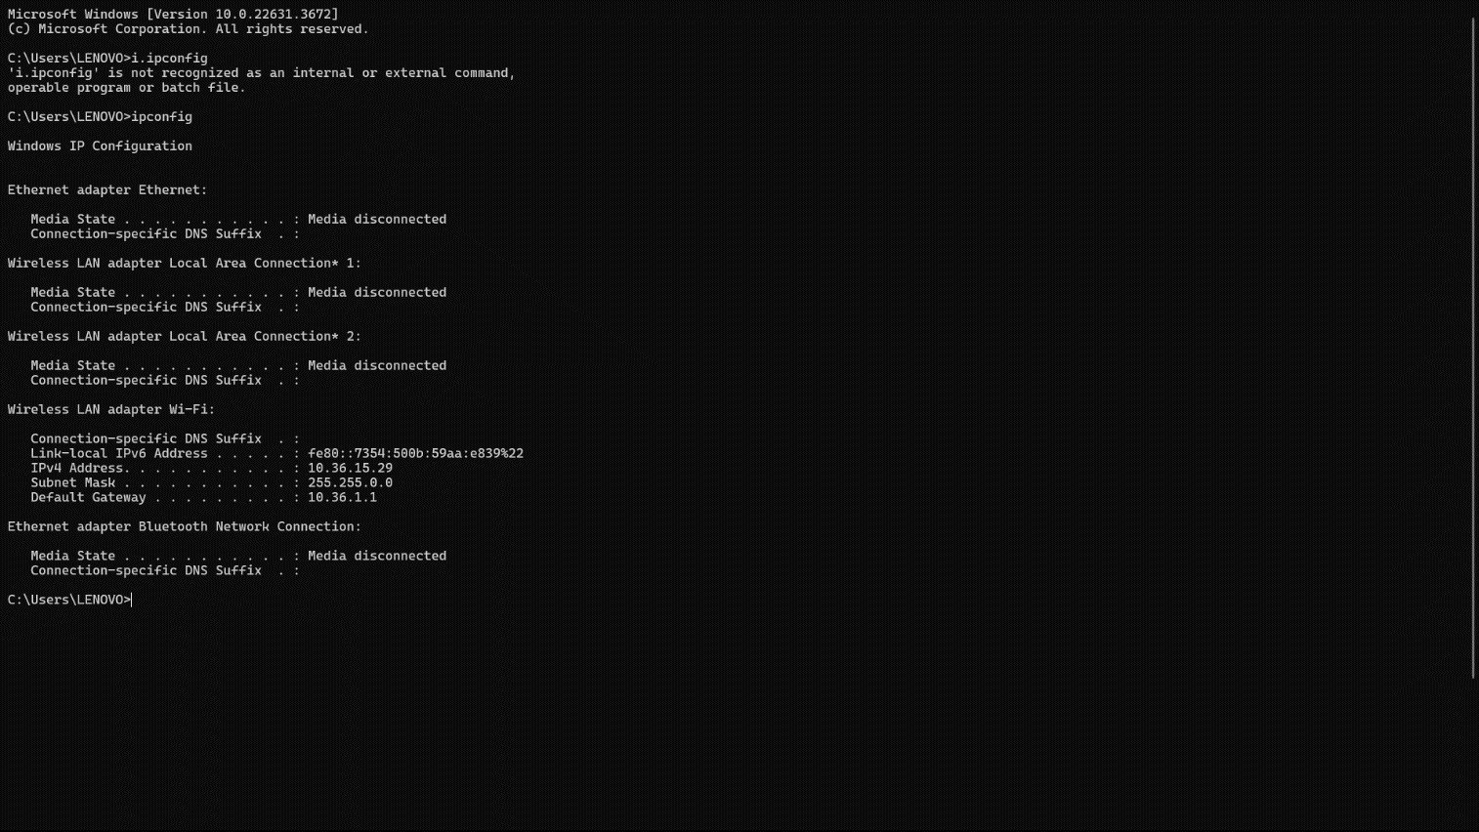

* Ipconfig /all

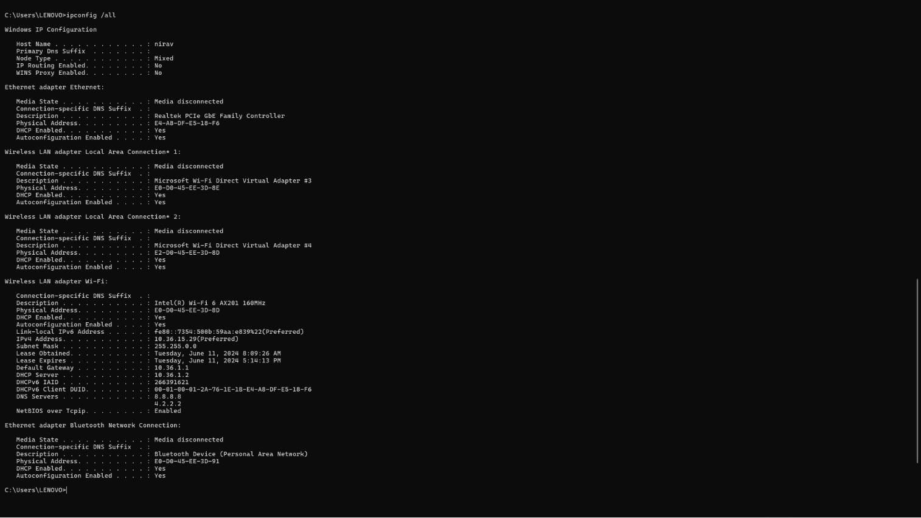

* Ipconfig /release

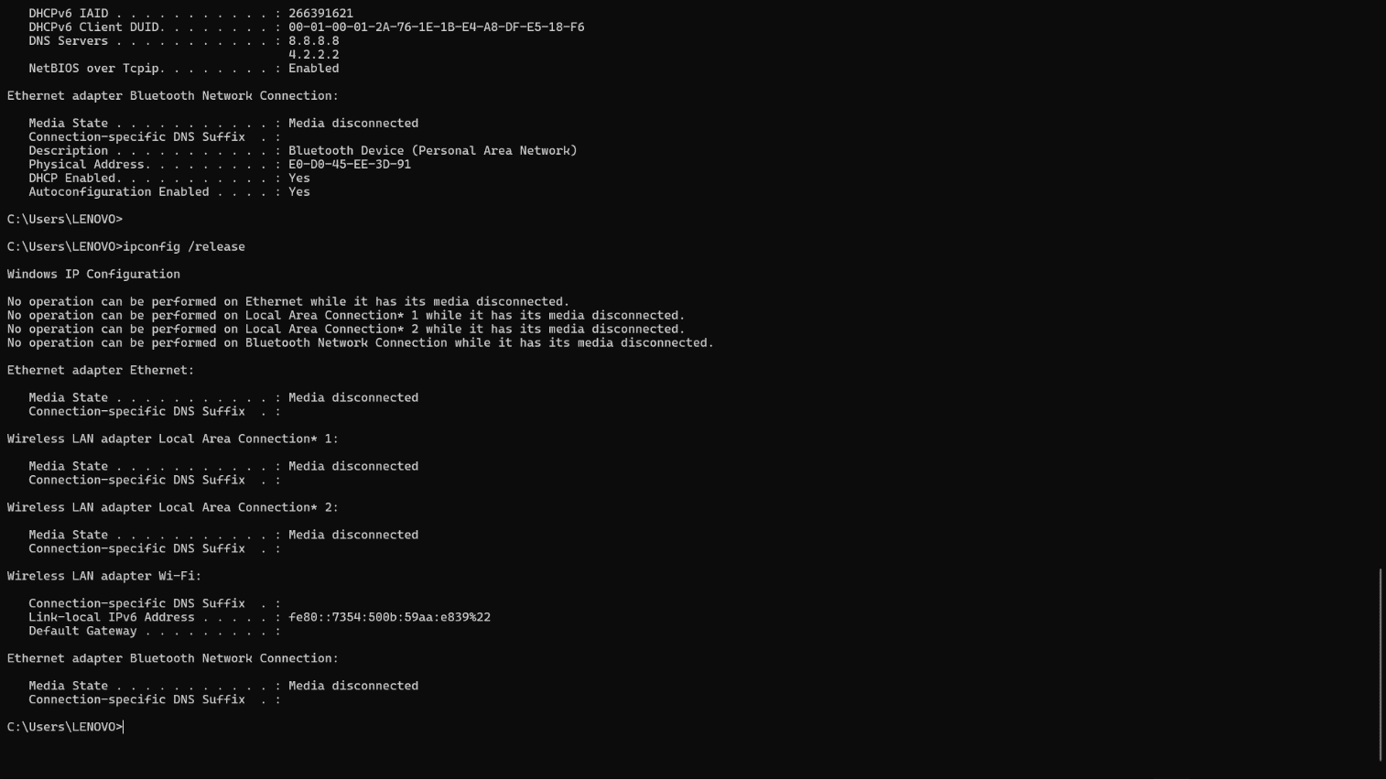

* Ipconfig /renew

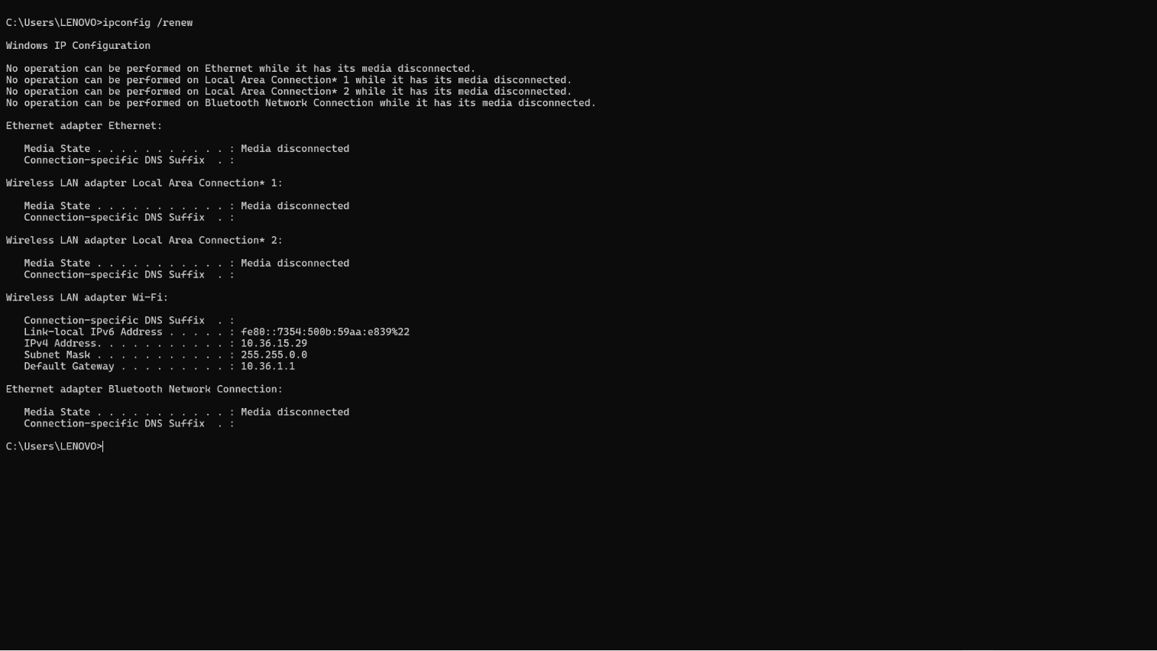

* Ipconfig /flushdns

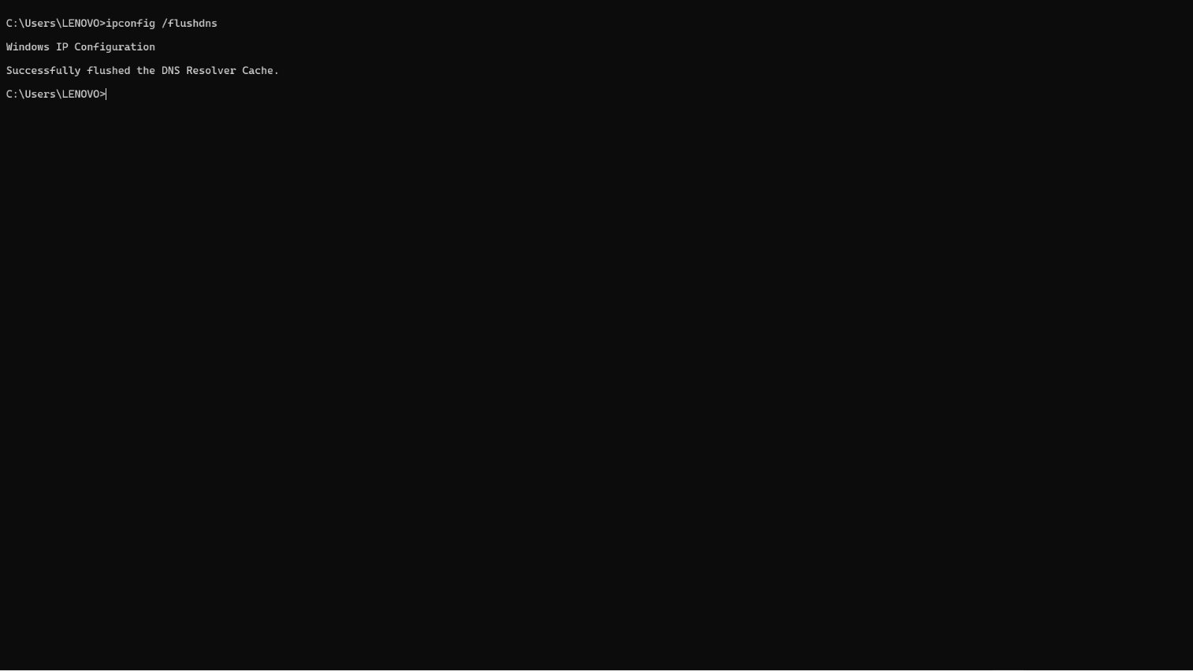

* Ipconfig /showclassid

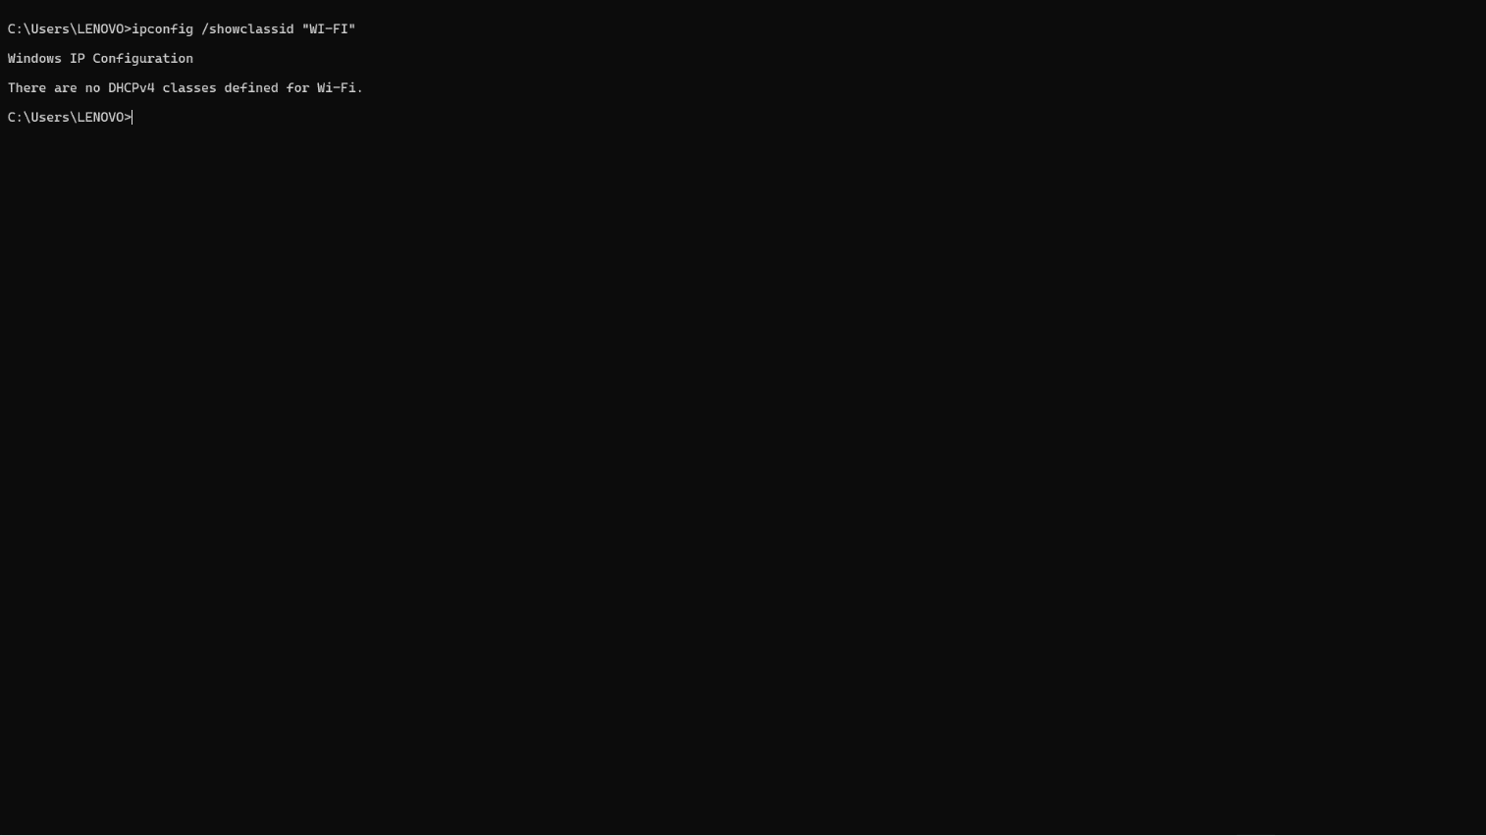

## ping

Description:

The ping command is a network utility used to test the reachability of a host on an Internet Protocol (IP) network and to measure the round-trip time for messages sent from the originating host to a destination computer. It helps diagnose network connectivity issues.

|  |  |  |
| --- | --- | --- |
| No. | Option | Description |
| 1 | ping -t example | Ping the specified host until stopped. |
| 2 | ping -n count example | Number of echo requests to send. |
| 3 | ping –a example | Resolve addresses to hostnames. |
| 4 | Ping -i TTL | Time To Live. |
| 5 | Ping -l size | Send Echo Request messages with a specified buffer size in bytes. |

### Implementation:

* ping –t [www.google.com](http://www.google.com)

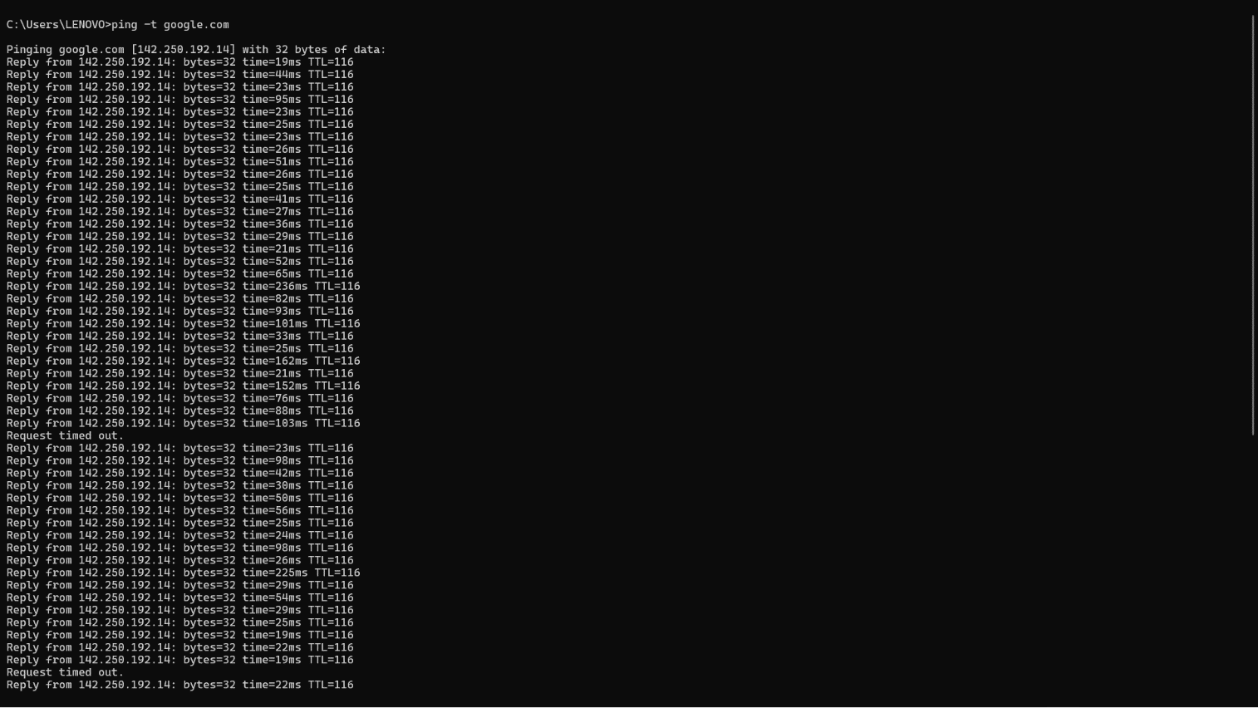

* ping –n count [www.google.com](http://www.google.com)

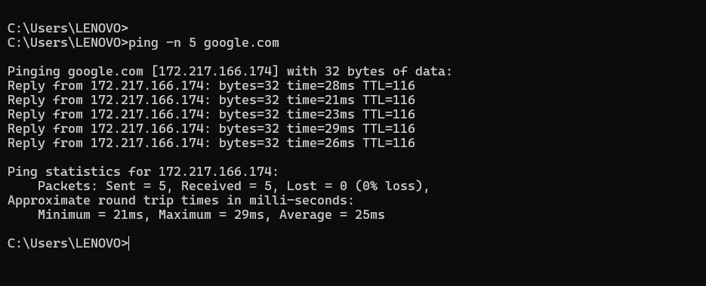

* ping –a google.com

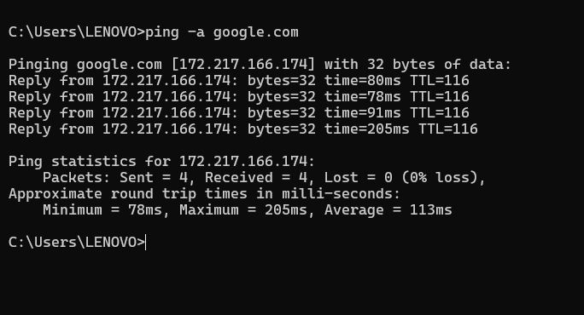

* ping -I TTL google.com

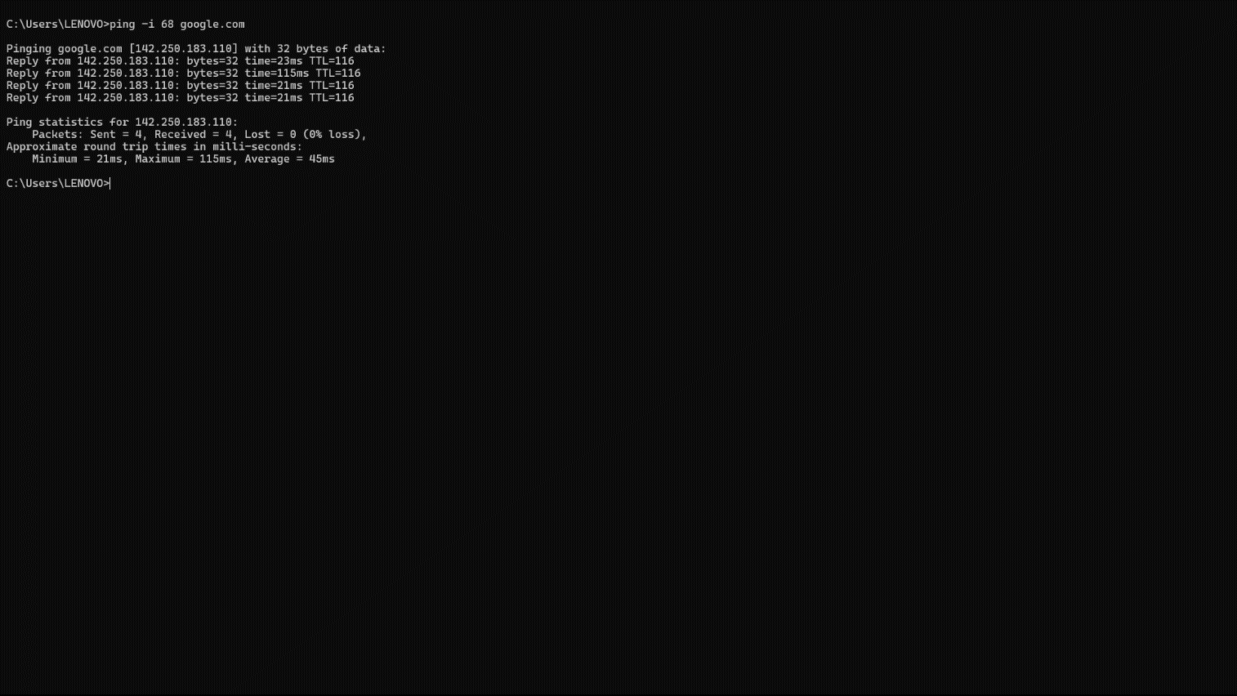

* ping -l size

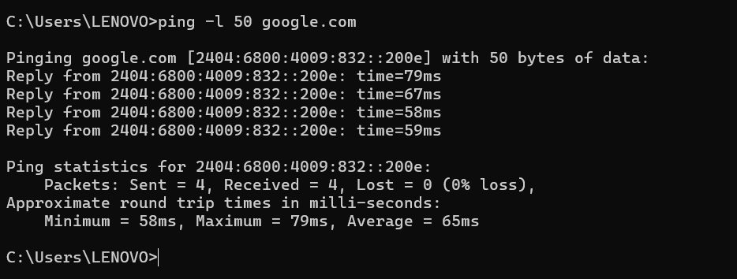

## getmac

### Description:

The getmac command is a Windows command-line utility that displays the Media Access Control (MAC) addresses for the network interfaces on a system. It can be used to retrieve the physical address (MAC address) of all network adapters, whether they are active or inactive.

|  |  |  |
| --- | --- | --- |
| No. | Option | Description |
| 1 | getmac /fo csv | Specifies the format in which the output is to be displayed.  Valid values: “TABLE”,“LIST”,“CSV” |
| 2 | getmac /v | Specifies that verbose output is displayed. |
| 3 | getmac /nh | Resolve addresses to hostnames. |
| 4 | getmac /s system | Specifies the remote system to connect to. |
| 5 | Getmac /u | Specifies the user context under which the command should execute |

### Implementation:

* getmac /fo csv1

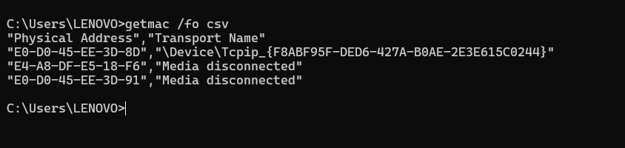

* getmac /v

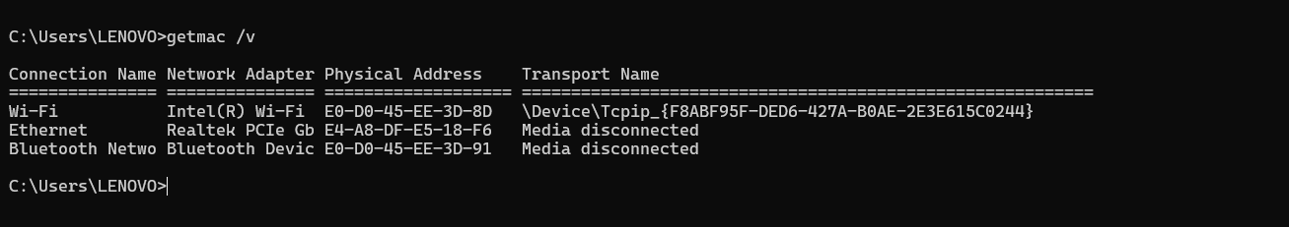

* getmac /nh

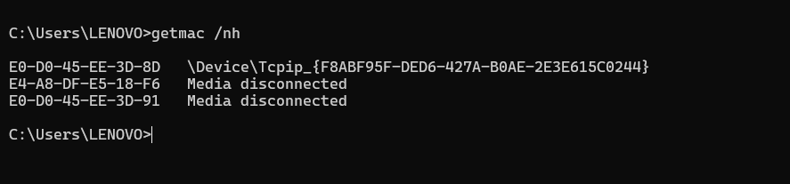

* getmac /s

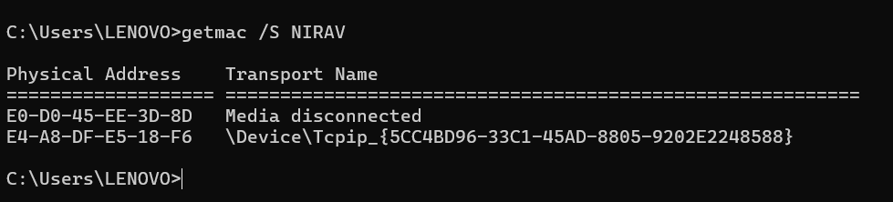

* getmac /u

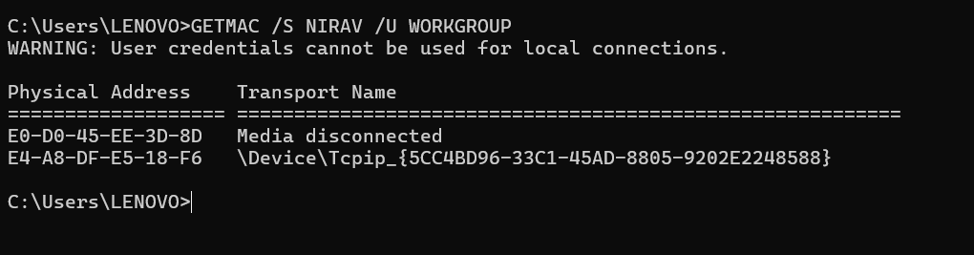

## systeminfo

### Description:

The ‘systeminfo’ command is a command-line utility in Windows that provides detailed information about the system's hardware and software configuration. It displays information such as the operating system version, hardware details, network configuration, and other system properties.

|  |  |  |
| --- | --- | --- |
| No. | Option | Description |
| 1 | systeminfo /S | Specifies the remote system to connect to. |
| 2 | systeminfo /FO format | Specifies the user context under which the command should execute.  Valid values: "TABLE", "LIST", "CSV". |
| 3 | systeminfo /NH | Specifies that the "Column Header" should not be displayed in the output.  Valid only for TABLE and CSV formats. |
| 4 | systeminfo /P | Specifies the password for the given user context. Prompts for input if omitted. |
| 5 | systeminfo /U | Specifies the user context under which the command should execute. |

### Implementation:

* systeminfo /S

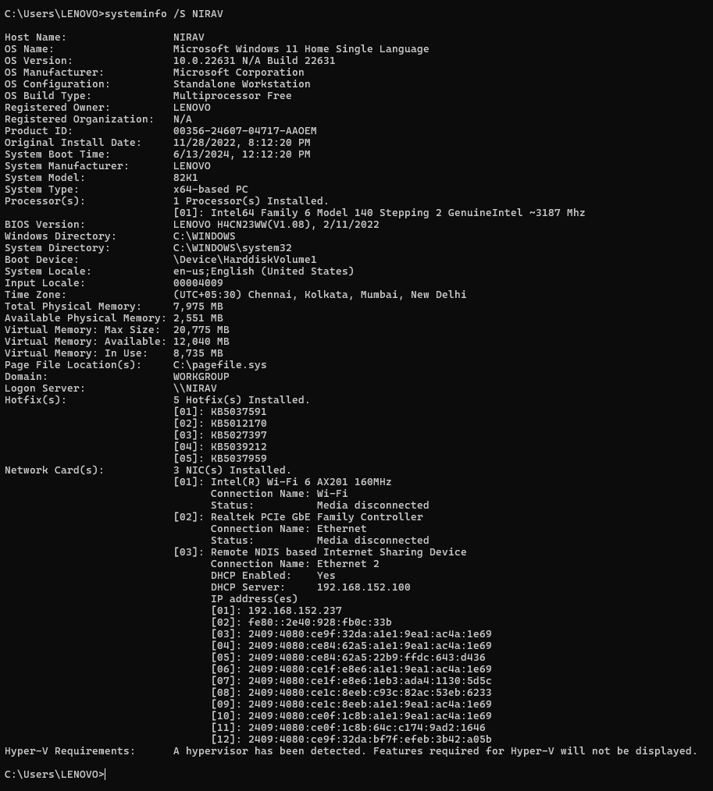

* systeminfo /FO format

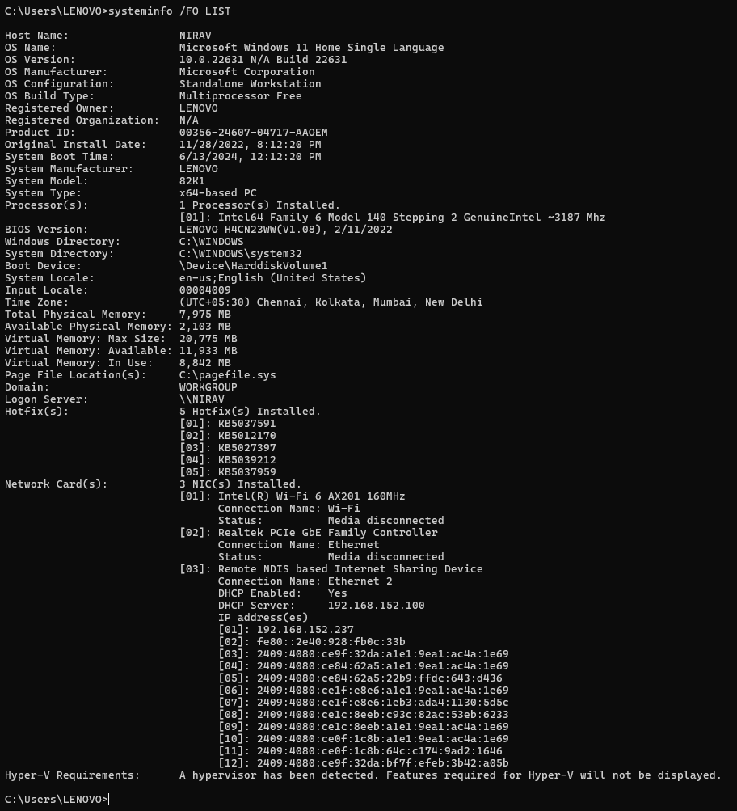

* systeminfo /U

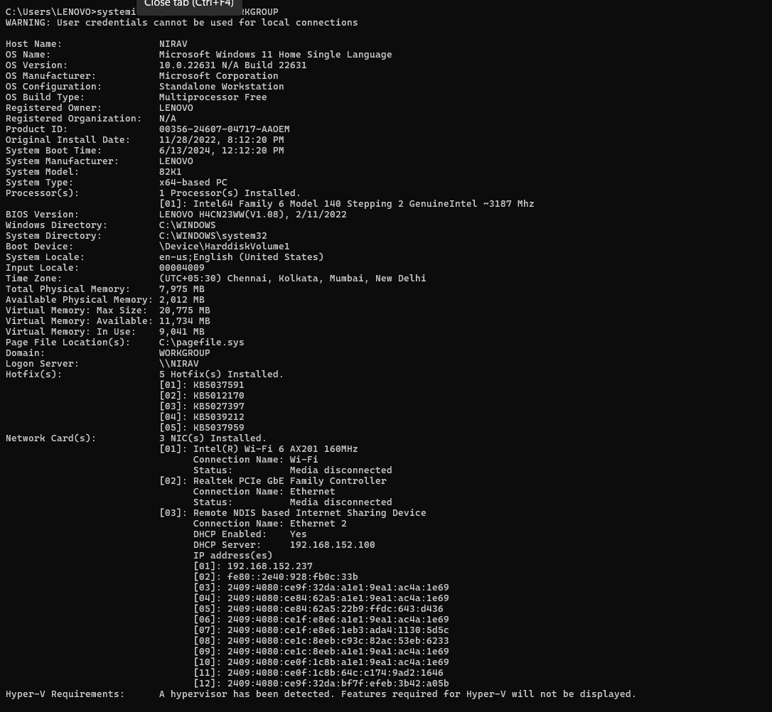

* systeminfo /NH

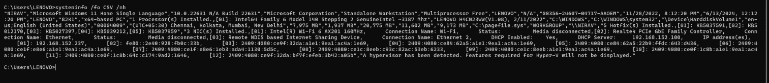

* systeminfo /P

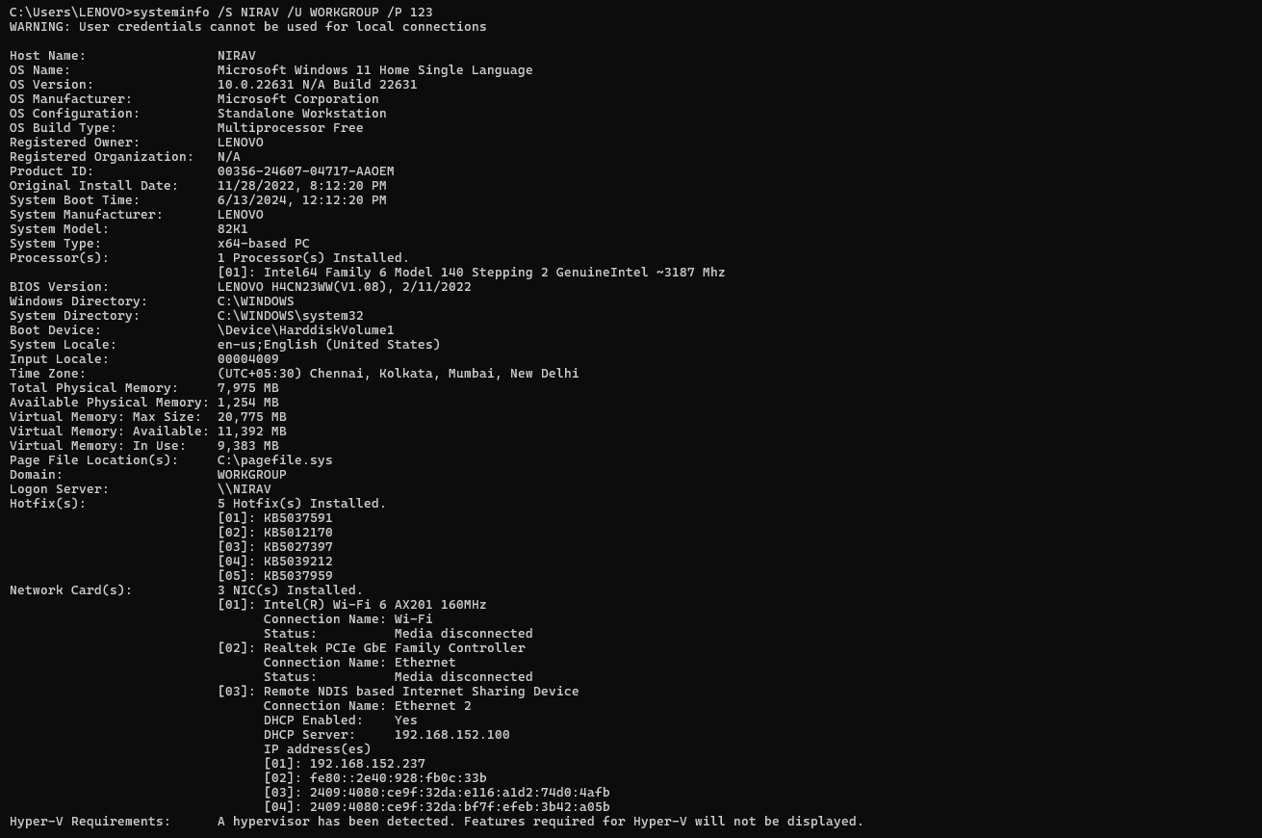

## tracert

### Description:

The ‘tracert’ (short for "trace route") command in Windows is a diagnostic tool used to track the path that packets take from your computer to a specified destination (like a website or IP address). It shows each hop along the route and the time it takes for each hop.

|  |  |  |
| --- | --- | --- |
| No. | Option | Description |
| 1 | tracert -d | Do not resolve addresses to hostnames. |
| 2 | tracert -h | Maximum number of hops to search for target. |
| 3 | tracert -w | Wait timeout milliseconds for each reply. |
| 4 | tracert -4 | Force using IPv4. |
| 5 | tracert -6 | Force using IPv6. |

### Implementation:

* tracert -d

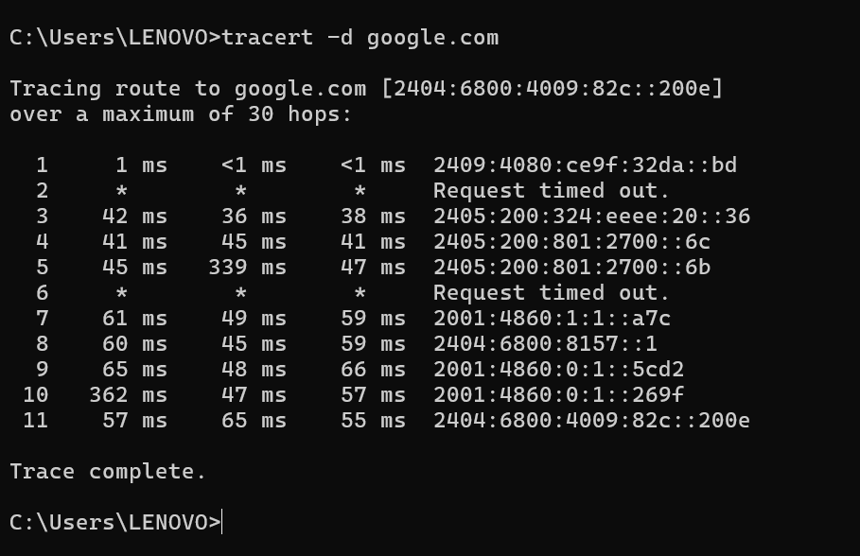

* tracert -h

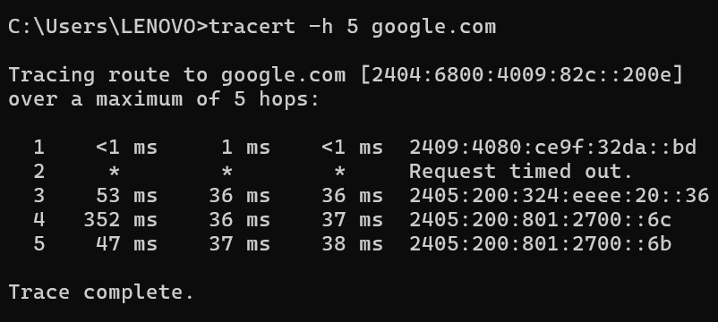

* tracert -w

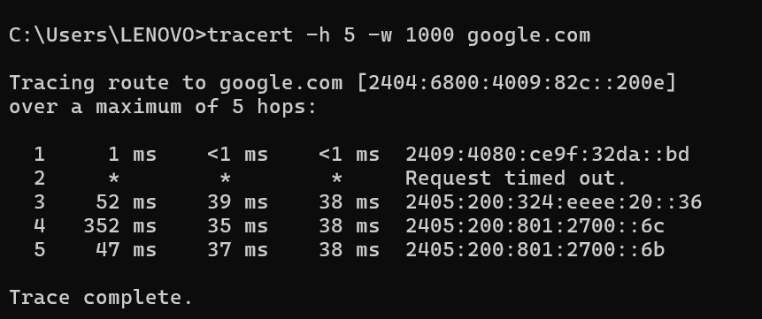

* tracert -4

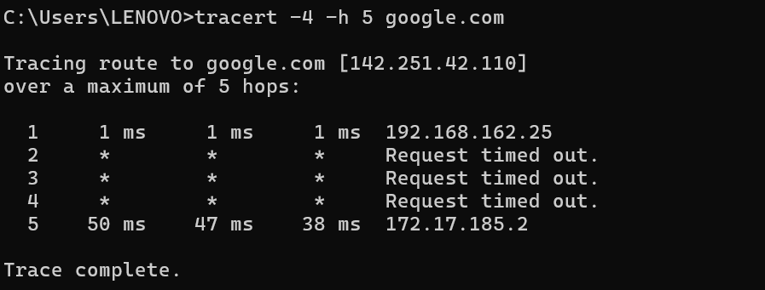

* tracert -6

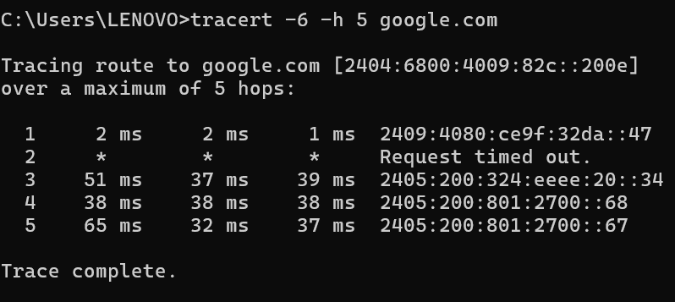

## netstat

### Description:

The ‘netstat’ (network statistics) command is a powerful networking tool in Windows that displays various network connections, routing tables, interface statistics, masquerade connections, and multicast memberships. It's widely used for diagnosing network issues and monitoring network performance.

|  |  |  |
| --- | --- | --- |
| No. | Option | Description |
| 1 | netstat –a | Displays all connections and listening ports. |
| 2 | netstat –e | Displays Ethernet statistics. This may be combined with the –s option. |
| 3 | netstat –f | Displays Fully Qualified Domain Names (FQDN) for foreign addresses. |
| 4 | netstat –i | Displays the time spent by a TCP connection in its current state. |
| 05 | netstat -x | Displays NetworkDirect connections, listeners, and shared endpoints. |

### Implementation:

* netstat -a

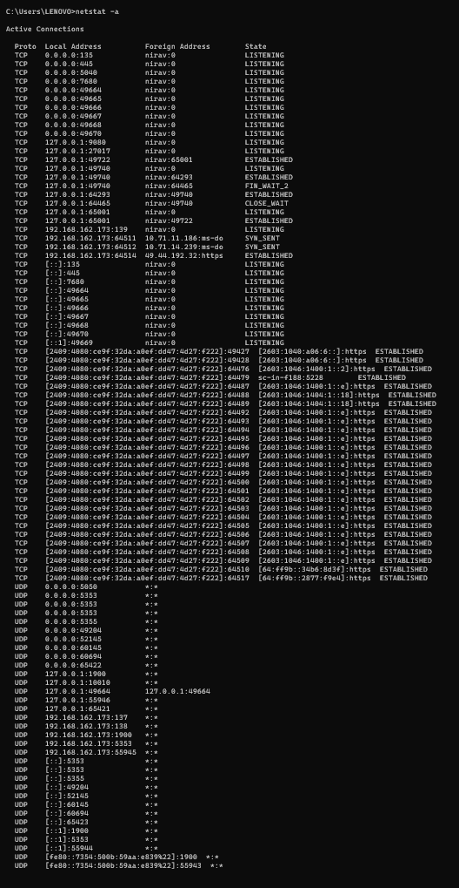

* netstat -e

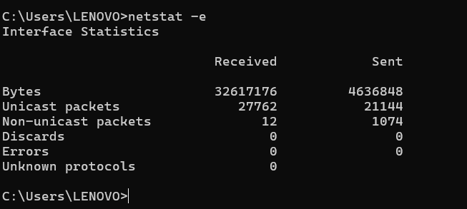

* netstat -f

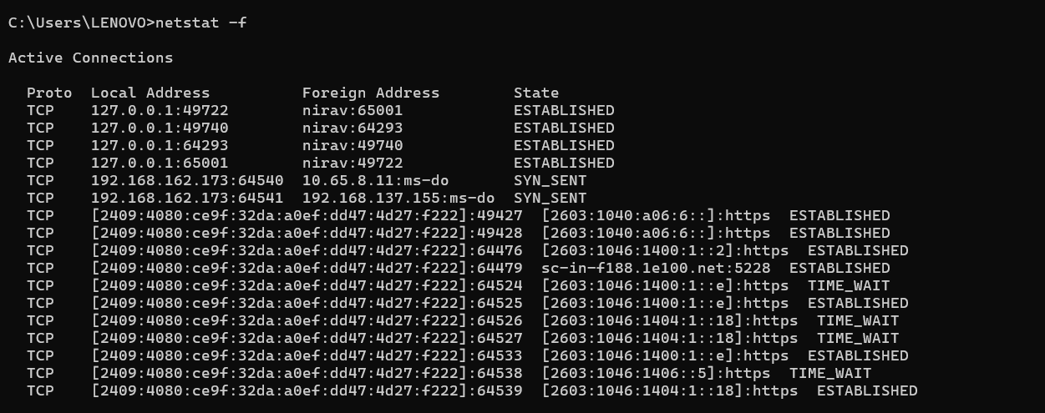

* netstat -i

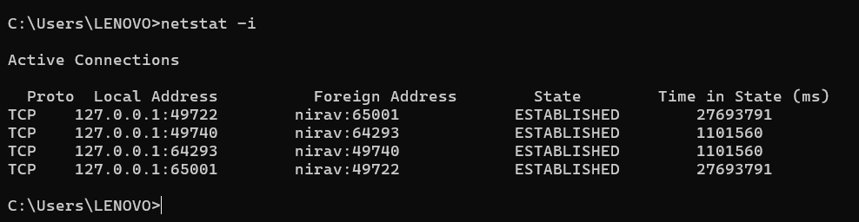

* netstat -x

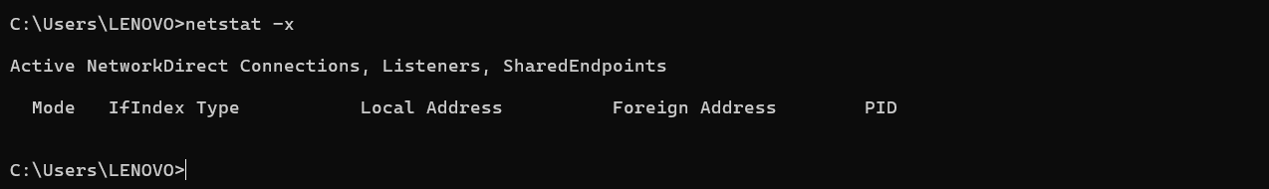

## nslookup

### Description:

The ‘nslookup’ (name server lookup) command is a network administration command-line tool available in many computer operating systems for querying the Domain Name System (DNS) to obtain domain name or IP address mapping or for any other specific DNS record.

|  |  |  |
| --- | --- | --- |
| No. | Option | Description |
| 1 | nslookup | Displays information that you can use to diagnose Domain Name System infrastructure |
| 2 | nslookup is | Lists information for a DNS domain |
| 3 | nslookup finger | Connects with the finger server on the current computer. |
| 4 | nslookup -port | Specify a different port. |
| 5 | nslookup -timeout | Set timeout for a reply. |

### Implementation:

* nslookup

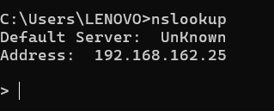

* nslookup is

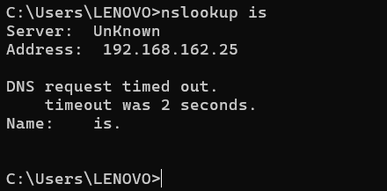

* nslookup finger

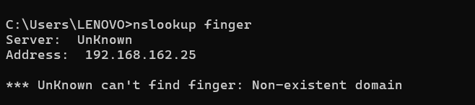

* nslookup -port

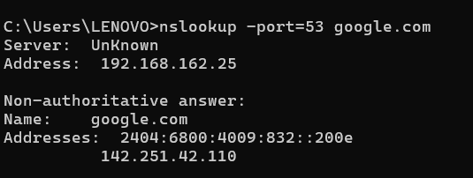

* nslookup -timeout

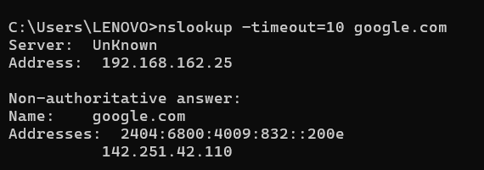

## hostname

### Description:

The ‘hostname’ command in Windows displays the name of the current host, which is typically the computer name.

|  |  |  |
| --- | --- | --- |
| No. | Option | Description |
| 1 | hostname –a | Displays all connections and listening ports. |
| 2 | hostname –e | Displays Ethernet statistics. This may be combined with the –s option. |

### Implementation:

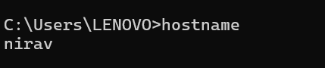

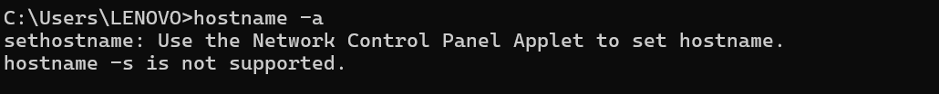

## pathping

### Description:

The ‘pathping’ command is a network diagnostic tool available in Windows that combines the functionality of ‘ping’ and ‘tracert’. It provides information about network latency and packet loss along the path between the local computer and a specified destination, similar to ‘tracert’, while also measuring the round-trip time of each hop, similar to ping.

|  |  |  |
| --- | --- | --- |
| No. | Option | Description |
| 1 | pathping –4 | Force using IPv4. |
| 2 | pathping –g | Loose source route along host-list. |
| 3 | pathping –n | Do not resolve addresses to hostnames. |
| 4 | pathping –q | Number of queries per hop. |
| 5 | pathping -w | Wait timeout milliseconds for each reply. |

### Implementation:

* pathping -4

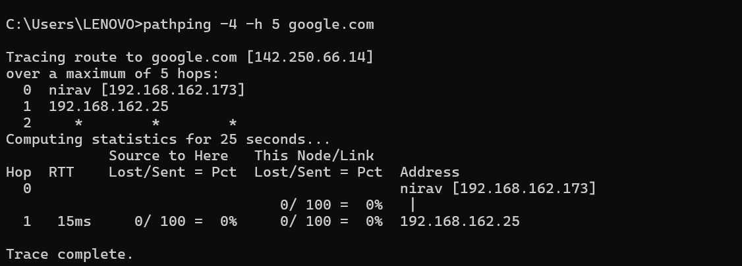

* pathping -g

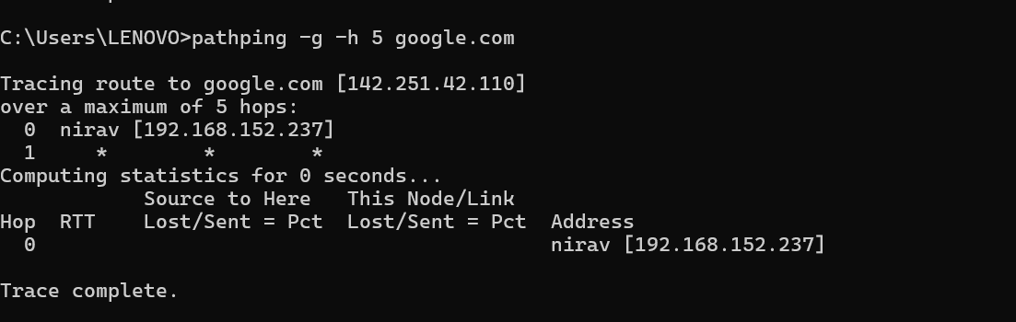

* pathping -n

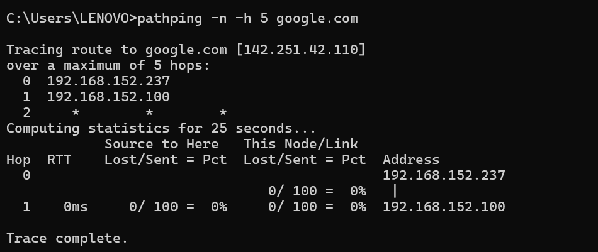

* pathping -q

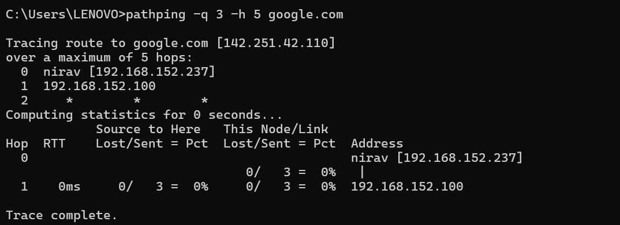

* pathping -w

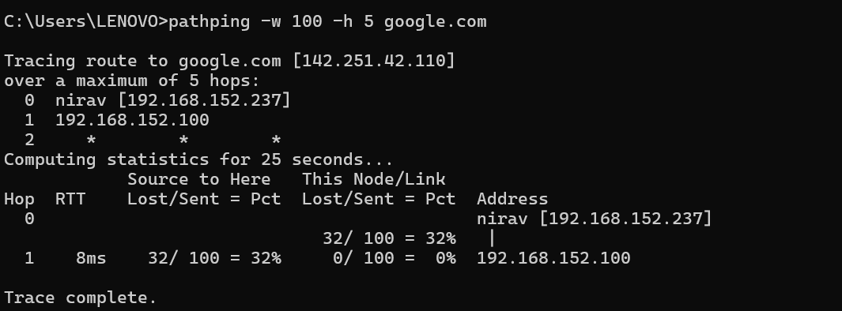

### Description:

The ‘arp’ (Address Resolution Protocol) command in Windows displays and modifies the local Address Resolution Protocol (ARP) cache, which maps IP addresses to physical MAC (Media Access Control) addresses on a local network.

|  |  |  |
| --- | --- | --- |
| No. | Option | Description |
| 1 | arp –a | Display ARP Cache for All Interfaces |
| 2 | arp -g | Displays the ARP cache for a specific interface. |
| 3 | arp /? | Display and modify the enteris in the address  resolution protocol. |

### Implementation:

* arp -a

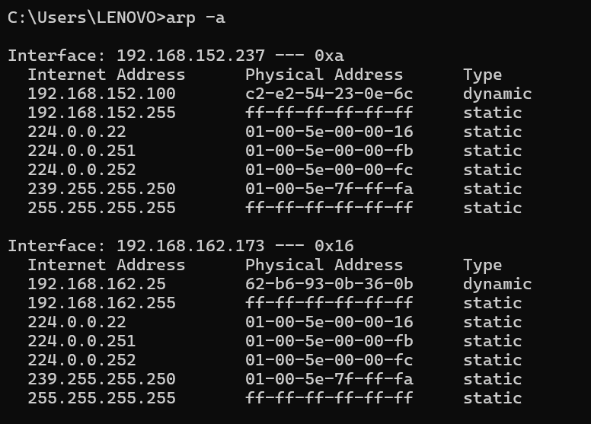

* arp -g

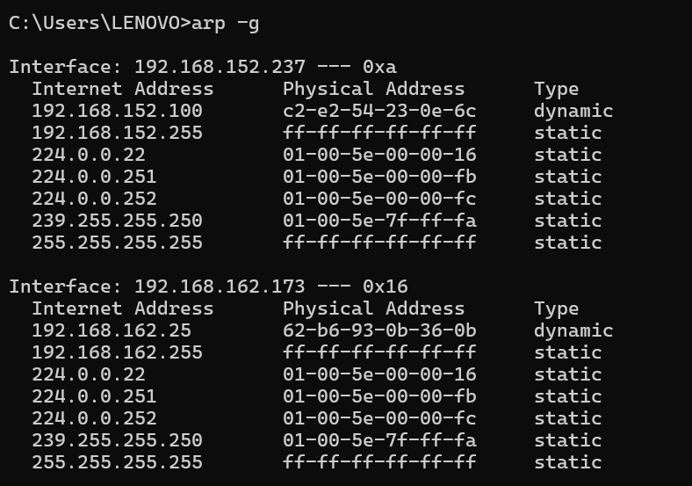

* arp /?

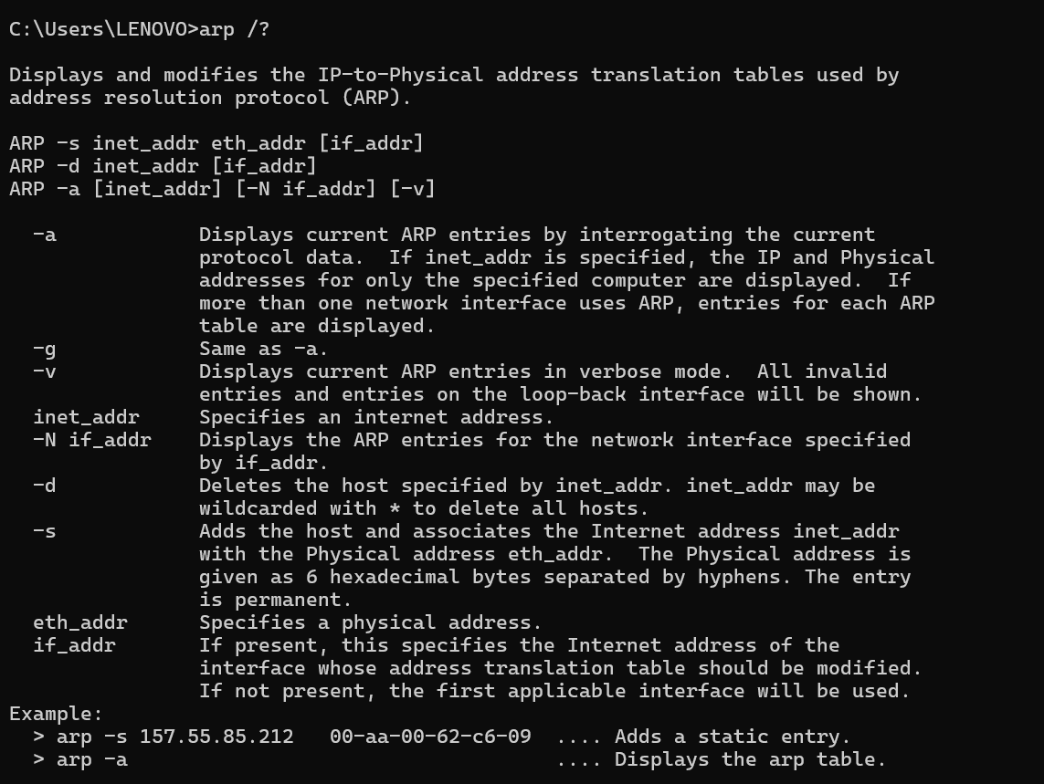

**Lab Practical #02:**

Study of different types of network cables & connectors and practically implement the cross-wired cable and straight through cable using clamping tool.

**Practical Assignment #02:**

1. List various networks cable and connectors. Also, write short description.
2. Give cross-wired cable and straight through cable diagram (Color Code wise).

## List various networks cable and connectors. Also, write short description.

1. **Network Cable Name: Coaxial Cable (RG-6/RG-59)**
   * **Network Cable Type:** Guided
   * **Description**: A coaxial cable is an electrical cable with a copper conductor and an insulator shielding around it and a braided metal mesh that prevents signal interference and cross talk. Coaxial cable is also known as **coax.**
   * Coaxial cables are commonly used for cable TV and broadband internet connections. They have a central conductor surrounded by insulation, a metallic shield, and an outer protective layer.
   * **Diagram**:

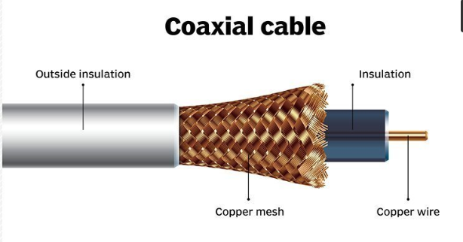

**RG6 Coaxial Cable**

**Diameter**: RG6 cables have a diameter of approximately 0.27 inches (6.86 mm).

Frequency Range: They support frequencies up to 3 GHz, suitable for most home applications.

**Attenuation**:RG6 cables have higher attenuation, meaning they lose signal strength more quickly over long distances.

**Applications**: These cables are commonly used for home internet and cable TV installations.

**Center Conductor**: Typically, RG6 cables use a copper-clad steel center conductor.

**Shielding**: RG6 cables can have single or dual-layer shielding.

**Flexibility**:They are more flexible and easier to install, especially in tight spaces.

**Cost**:RG6 cables are generally less expensive compared to RG11 cables.

**Max Distance**:RG6 cables are effective over shorter distances compared to RG11.

**RG11 Coaxial Cable**

**Diameter**:RG11 cables have a larger diameter of approximately 0.40 inches (10.29 mm).

**Frequency Range**:Like RG6, RG11 cables support frequencies up to 3 GHz.

**Attenuation**:RG11 cables have lower attenuation, meaning they maintain signal quality over longer distances.

**Applications**:RG11 cables are used for long-distance cable runs and professional applications where signal quality is critical.

**Center** **Conductor**:RG11 cables typically use a solid copper center conductor for better conductivity.

**Shielding**: RG11 cables are usually quad-shielded, offering superior protection against interference.

**Flexibility**:RG11 cables are less flexible and more rigid, making them harder to install in tight spaces.

**Cost**: RG11 cables are more expensive due to their enhanced performance and materials.

**Max Distance**:RG11 cables can effectively carry signals over longer distances than RG6 cables.

1. **Network Cable Name: USB Cable (Universal Serial Bus)**
   * **Network Cable Type:** Unguided
   * **Description**: The term USB stands for "Universal Serial Bus". USB cable assemblies are some of the most popular cable types available, used mostly to connect computers to peripheral devices such as cameras, camcorders, printers, scanners, and more.
   * USB cables are primarily used for connecting peripheral devices, such as printers, keyboards, and external storage devices, to computers. They also support networking through USB-to-Ethernet adapters.
   * **Diagram**:

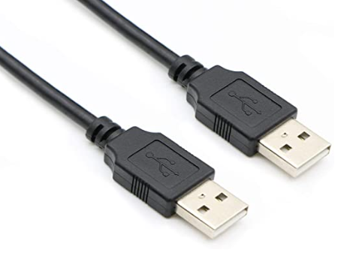

1. **Network Cable Name: Fiber Optic Cable**
   * **Network Cable Type:** Guided
   * **Description**: A fiber-optic cable contains anywhere from a few to hundreds of optical fibers within a plastic casing. Also known as optic cables or optical fiber cables, they transfer data signals in the form of light and travel hundreds of miles significantly faster than those used in traditional electrical cables.
   * **Diagram**:

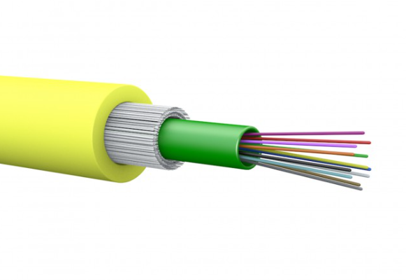

1.**Multimode**:-

Multimode fibre can carry multiple light rays (modes) at the same time by having varying optical properties at the core; essentially light travelling the shortest path (down the middle) travels the slowest.The larger core simplifies connections and takes advantage of the lower cost LED & VCSEL technologies which operate in the 850nm window. Due to dispersion the range is limited so it tends to be used as premises cabling when less than a kilometre. It comes in two core sizes, 62.5 and 50 microns.

2. **Singlemode**:-

Singlemode fibre has a much smaller core size of 9 microns and has a single light path and can travel much longer distances of up to 100km. These require more expensive electronics which operate in the 1310 and 1550nm windows and are typically used in longer distance LAN’s, Cable TV and telephony applications.

1. **Network Cable Name: Twisted Pair Cable**
   * **Network Cable Type:** Guided
   * **Description**: Twisted pair cable is a type of network cable that consists of pairs of insulated copper wires twisted together in a specific pattern. It is widely used in Ethernet networks for transmitting data signals.
   * **Diagram**:

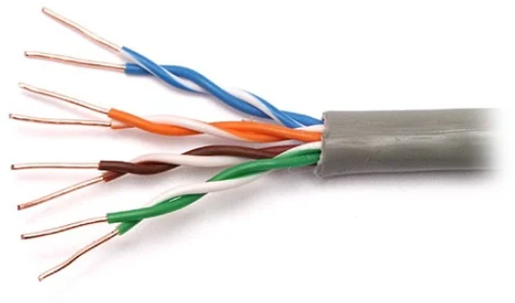

**Twisted Pair Cables are further of two types :**

1. **Unshielded Twisted Pair Cables (UTP) :**

* **Description:**These are a pair of two insulated copper wires twisted together without any other insulation or shielding and hence are called unshielded twisted pair cables. They reduce the external interference due to the presence of insulation. Unshielded twisted pair cables are arranged in pairs so that we can add a new connection whenever required. The DSL or telephone lines in our houses have one extra pair in them.

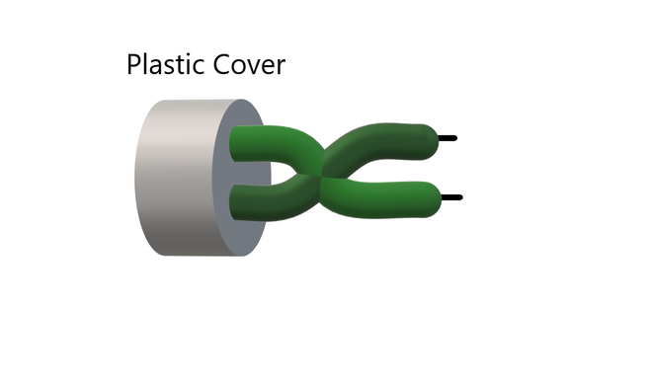

1. **Shielded Twisted Pair Cables (STP) :**

* **Description:**These types of cables have extra insulation or protective covering over the conductors in the form of a copper braid covering. This covering provides strength to the overall structure of the cable. It also reduces noise and signal interference in the cable.

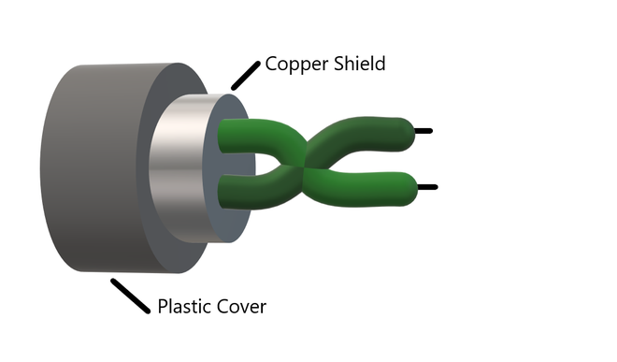

**Difference:**

|  |  |
| --- | --- |
| Shielded Cable | Unshielded Cable |
| Expensive | Less costly compared to shielded cable |
| Less flexible | Flexible |
| Bigger in dia than unshielded | Diameter less than shielded |
| No technical issues including EMI | EMI may cause problem |
| Suitable for high-traffic networks | Not advisable for networks with increased traffic |
| Ideal for bigger firms | Suitable for offices and offices with fewer traffic with large network area |

1. **Network Cable Name: HDMI Cable (High-Definition Multimedia Interface)**
   * **Network Cable Type:** Unguided
   * **Description:** HDMI cables are used to transmit audio and video signals between devices, such as computers, game consoles, Blu-ray players, and TVs. They support high-definition video and multi-channel audio.
   * **Diagram**:

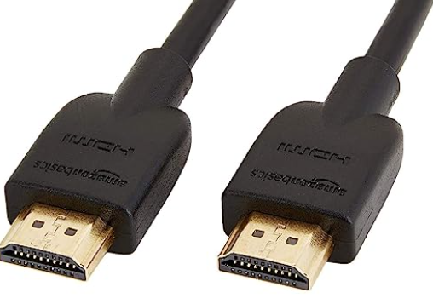

1. **Network Cable Name: DisplayPort Cable:**
   * **Network Cable Type:** Unguided
   * **Description**: DisplayPort cables are commonly used to connect computers and displays, such as monitors and projectors. They support high-definition video and audio signals.
   * **Diagram**:

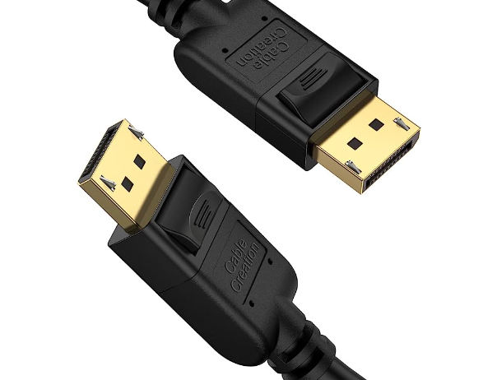

1. **Network Cable Name: Thunderbolt Cable**
   * **Network Cable Type:** Unguided
   * **Description**: Thunderbolt cables provide high-speed data transfer and video output capabilities. They are commonly used for connecting external devices, such as storage drives and displays, to computers.
   * **Diagram**:

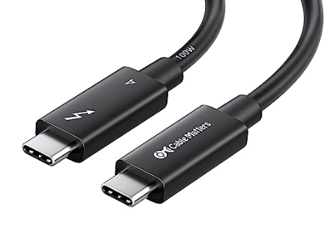

1. **Network Cable Name: T Type Connecter**
   * **Network Cable Type:** Unguided
   * **Description**: A fiber-optic cable contains anywhere from a few to hundreds of optical fibers within a plastic casing. Also known as optic cables or optical fiber cables, they transfer data signals in the form of light and travel hundreds of miles significantly faster than those used in traditional electrical cables
   * **Diagram**:

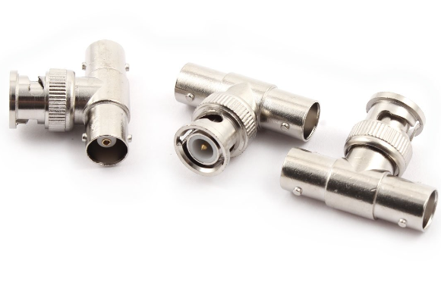

1. **Network Cable Name: RJ-45 connecter**
   * **Network Cable Type:** Guided
   * **Description**: A fiber-optic cable contains anywhere from a few to hundreds of optical fibers within a plastic casing. Also known as optic cables or optical fiber cables, they transfer data signals in the form of light and travel hundreds of miles significantly faster than those used in traditional electrical cables
   * **Diagram**:

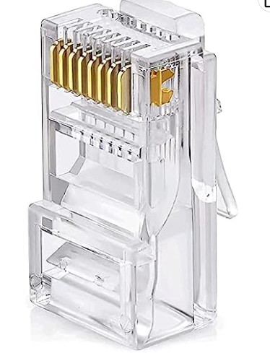

## Give cross-wired cable and straight through cable diagram (Color Code wise).

1. Cross-wired Cable Diagram (Color Code)

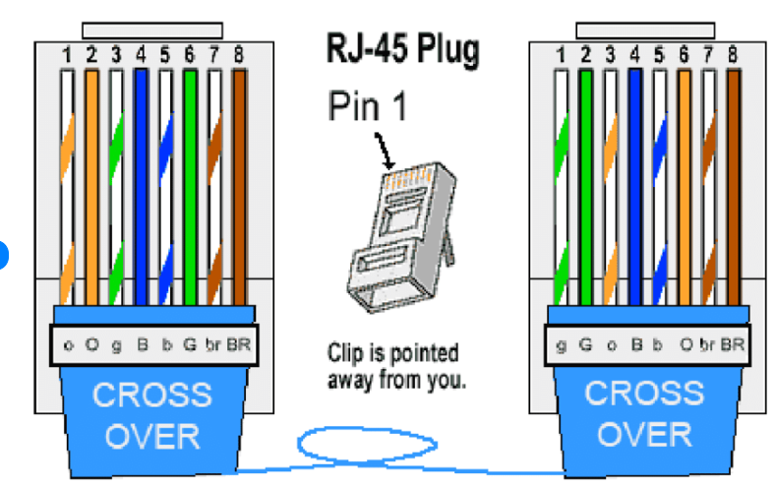

1. Straight Through Cable Diagram (Color Code)

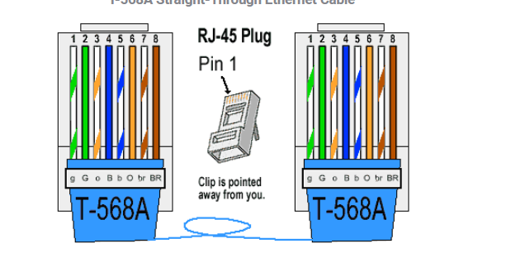

**Lab Practical #03:**

Study of different network devices in detail.

**Practical Assignment #03:**

1. Give difference between below network devices.

* Hub and Switch
* Switch and Router
* Router and Gateway

1. Working of below network devices:
   * Switch
   * Router
   * Gateway

# Hub and Switch

|  |  |  |
| --- | --- | --- |
| No. | Hub | Switch |
| 1 | Physical layer. Hubs are classified as Layer 1 devices per the OSI model. | Data link Layer. Network switches operate at Layer 2 of the OSI model. |
| 2 | Passive Device (Without Software). | Active Device (With Software) & Networking device. |
| 3 | Hubs always perform frame flooding : may be unicast, multicast or broadcast. | First broadcast : then unicast & multicast as needed. |
| 4 | A network hub cannot learn or store MAC address. | A network switch stores MAC addresses in a lookup table. |
| 5 | Half duplex. | Full duplex. |

# Switch and Router

|  |  |  |
| --- | --- | --- |
| No. | Switch | Router |
| 1 | LAN for office, Data Center or Campus environment. | WAN for Office, Data center or Campus environment. |
| 2 | Does not support MPLS and VPN services. | Router provides MPLS and VPN services like PPP etc. |
| 3 | Forwarding is performed by specialized ASICs. | Performed by software. |
| 4 | Smaller routing table compared to router. | Considerably bigger to support multiple route entires. |
| 5 | Transmission mode : Half & Full duplex | Transmission mode : Full duplex. |

# Router and Gateway

|  |  |  |
| --- | --- | --- |
| No. | Router | Gateway |
| 1 | Can only work with similar networks. | Can work with dissimilar networks |
| 2 | Using TCP/IP and UDP protocols. | Using different protocols. |
| 3 | Routes data packet from one network to another based on internal routing tables. | Converts the data packets protocols from one format to another |
| 4 | Support both static and dynamic routing. | Doesn’t support both. |
| 5 | Connect purely dedicated physical hardware. | Can connect a physical and virtual devices. |

# Working of below network devices:

1. Switch

* When the source wants to send the data packet to the destination, the packet first enters the switch and the switch reads its header and finds the MAC address of the destination to identify the device then it sends the packet out through the appropriate ports that lead to the destination devices.
* Switch established a temporary connection between the source and destination for communication and terminates and connection once the conversation is done. Also, it offers full bandwith to network traffic going to and from a device simultaneously to reduce collision.

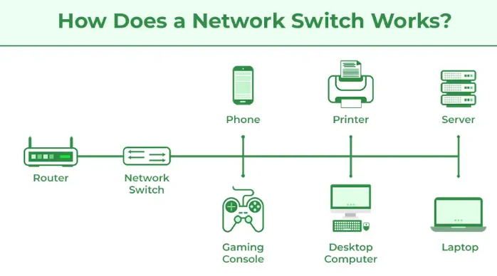

1. Router

* Consider a router as an air traffic controller, and consider data packets as planes flying to various airports. Each packet must be directed as quickly as possible to its destination, just as each plane has a distinct destination and travels a distinct route. A router assists in guiding data packets to their intended IP address, just like an air traffic controller ensures that aircraft reach their destinations without getting lost or experiencing significant disruptions in a route.
* An internal routing table, which is a list of routes to different network destinations, is used by a router to effectively direct packets. In order to determine the destination of a packet, the router first scans its header. Then, it consults the routing table. Forward packet to next packet.

1. Gateway

* The user end’s application made a request for a certain amount of data via its portal to the gateway. For example, A smart door made a request for the data type : “password” and send this request to the gateway.
* The gateway sends this request for a password to the server.
* The server receives the request and search for the data type : “password” for a certain “id” and made the data “password” transfer to the gateway.
* The data is then sent to the smart door interface where it is matched with the data entered for data type : “password”. If these two data matches then the door gets unlocked.

**Lab Practical #04:**

Installation of Network Simulator (Packet Tracer) and Implement different LAN topologies.

**Practical Assignment #04:**

1. **Create a simple network with switch and two or more pc. Also check connectivity between them using ping command or PDU utility.**

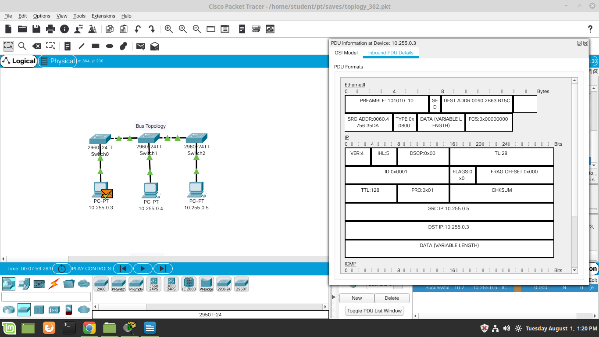

1. **Implement different topologies in packet tracer.**
   1. **Bus**



* 1. **Ring**

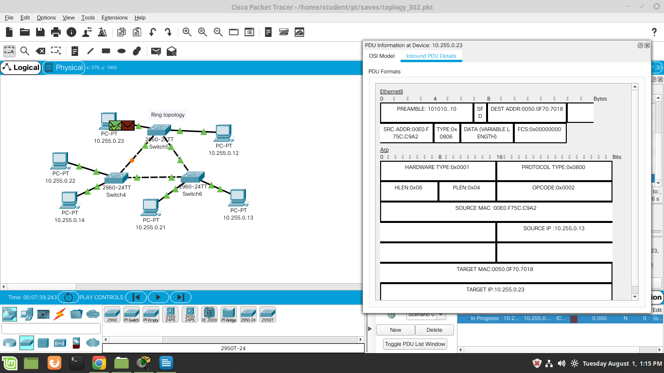

* 1. **Star**

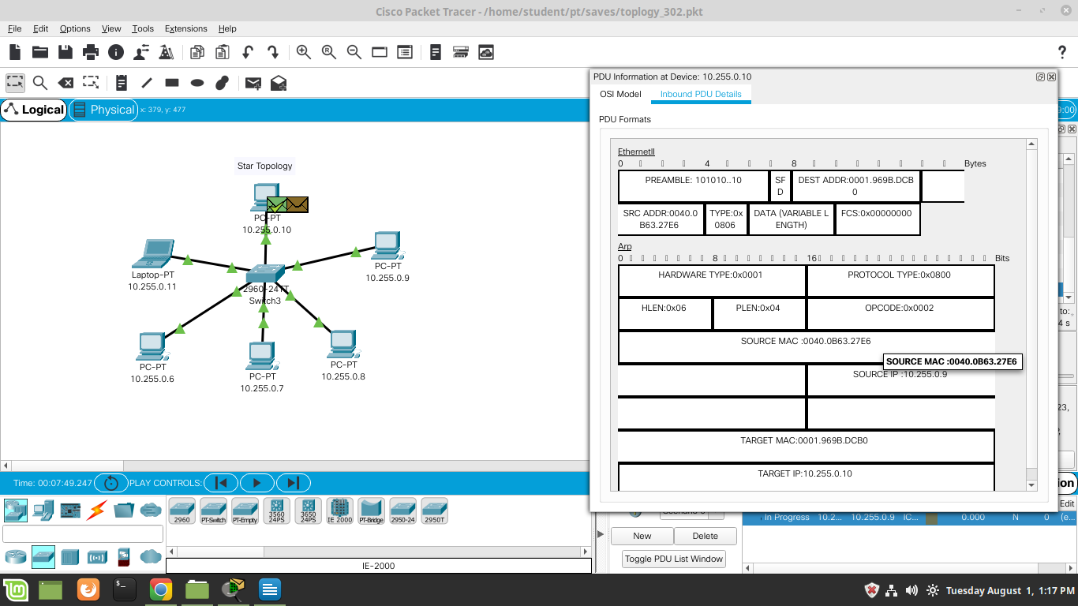

* 1. **Mesh**

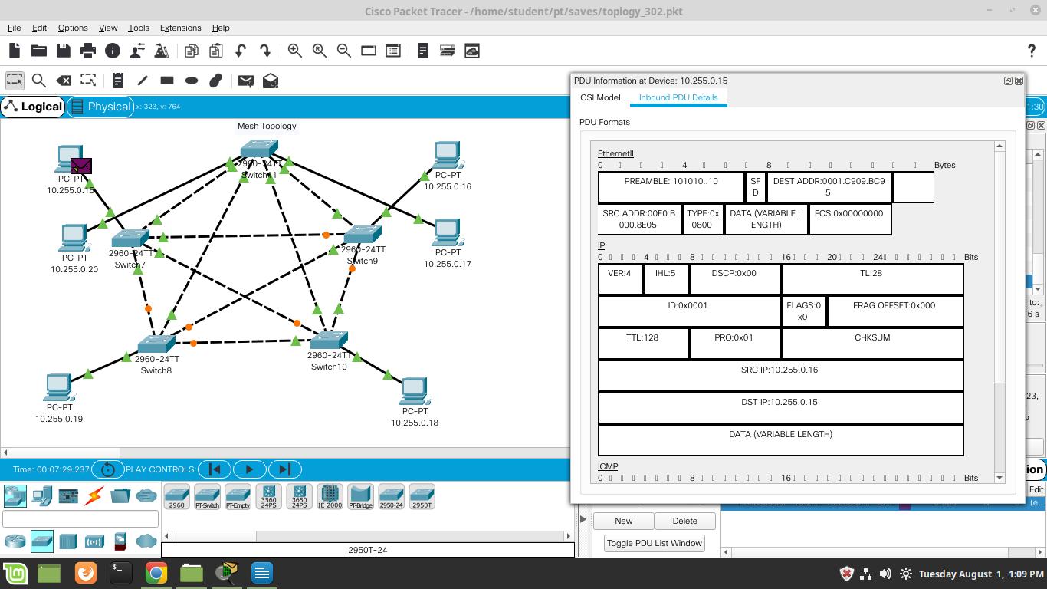

* 1. **Tree**

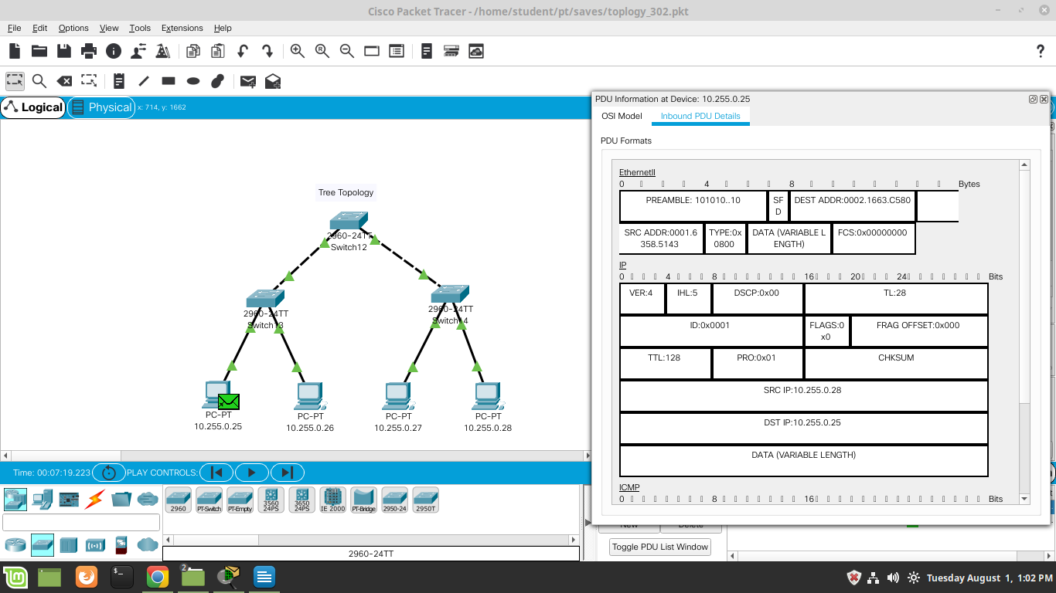

**Lab Practical #05:**

Study the concept of VLAN using packet tracer.

**Practical Assignment #05:**

1. **Implement the different network structures in VLAN and VLAN trunking. Also check connectivity between them using ping command or PDU utility.**
2. **VLAN - 1 :**

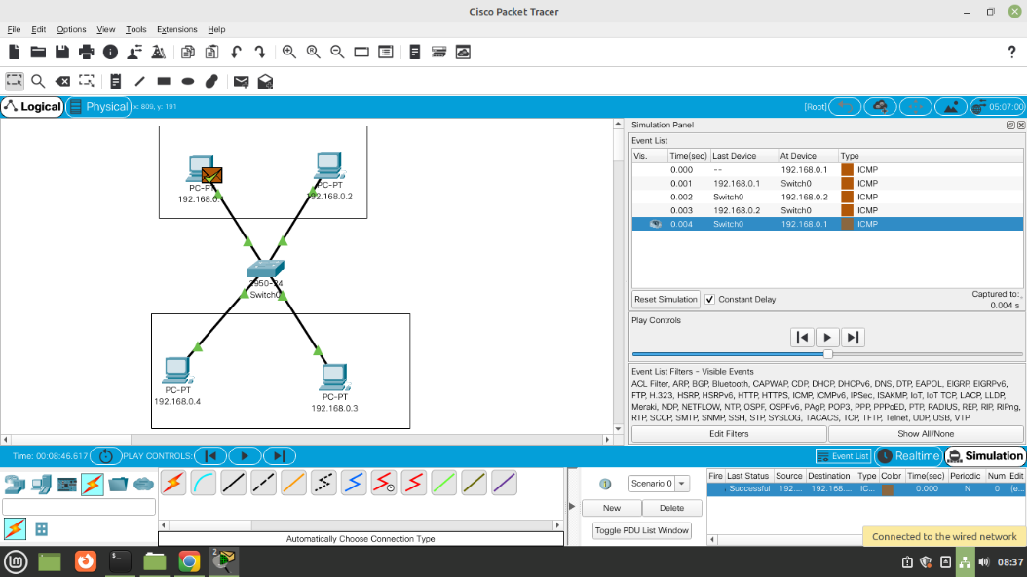

1. **VLAN – 1 (Database) :**

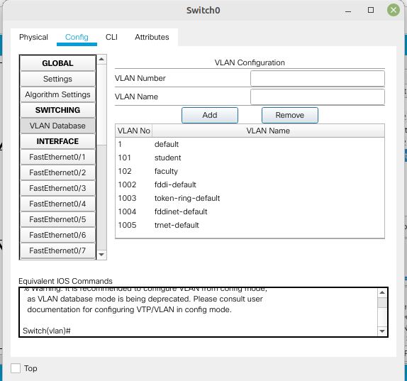

1. **VLAN – 1 (PDU Information) :**

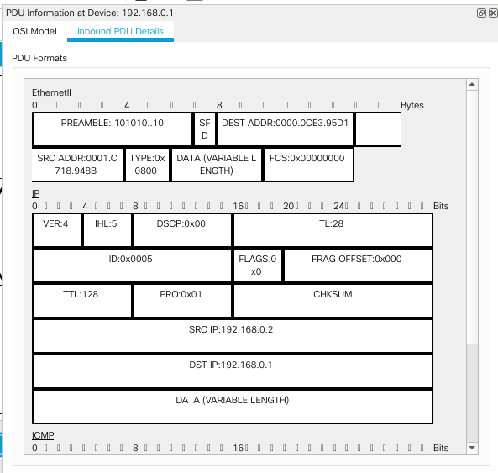

1. **VLAN - 2 :**

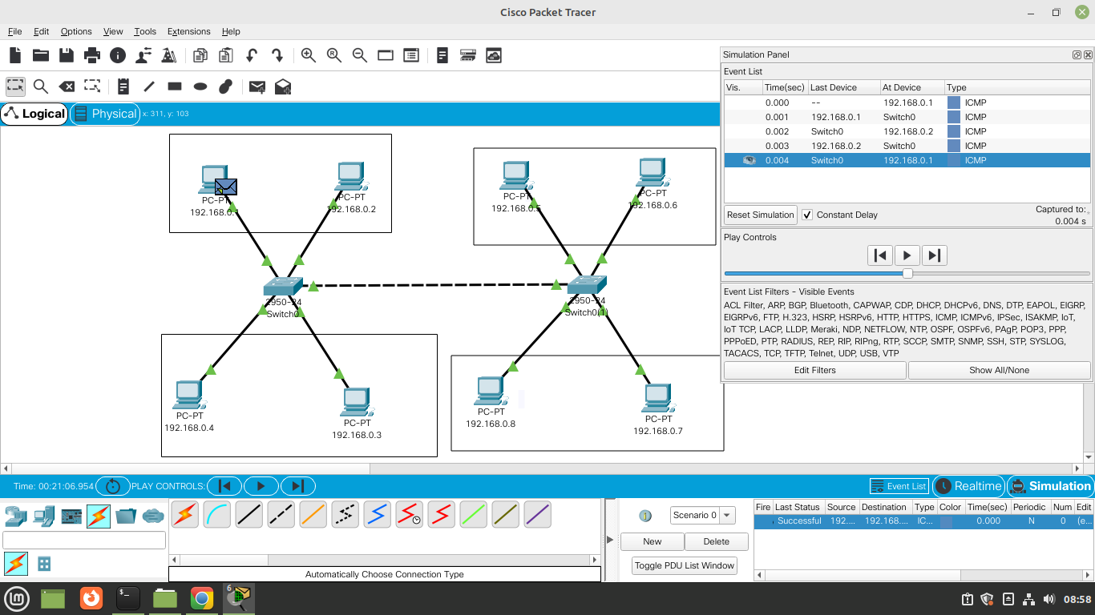

1. **VLAN - 2 (Database) :**

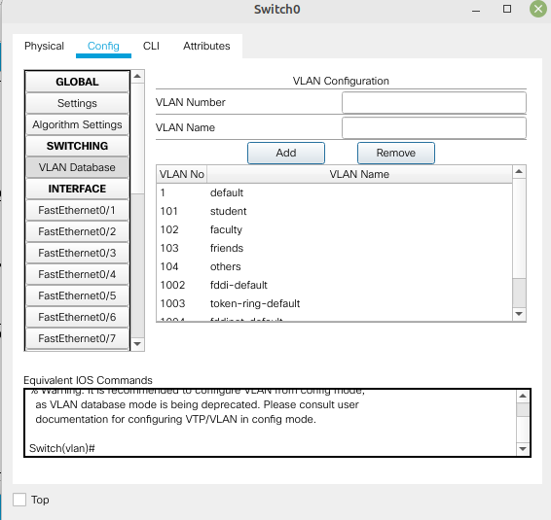

1. **VLAN – 2 (PDU Information) :**

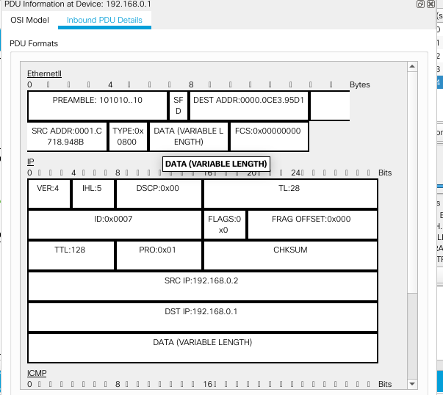

1. **VLAN - 3 :**

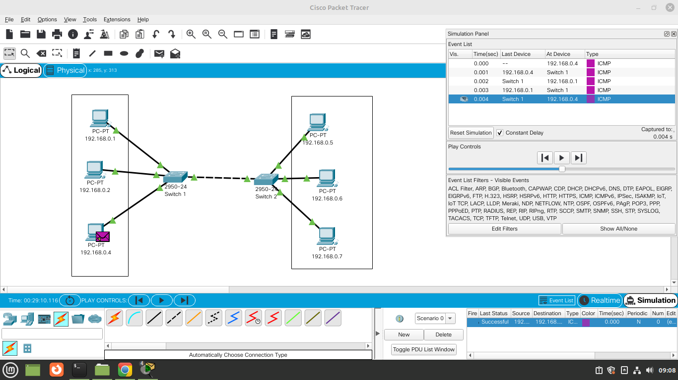

1. **VLAN – 3 (Database) :**

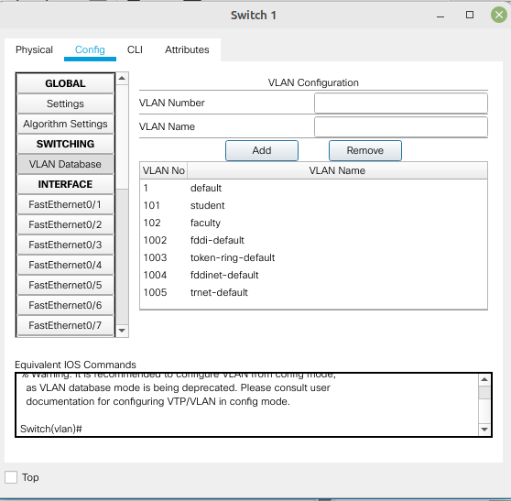

1. **VLAN – 3 (PDU Information) :**

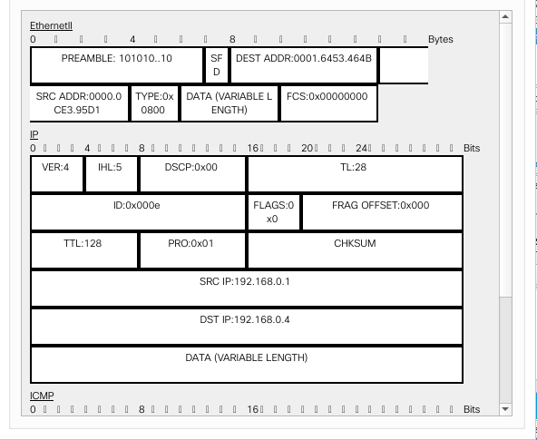

1. **VLAN - 4 :**

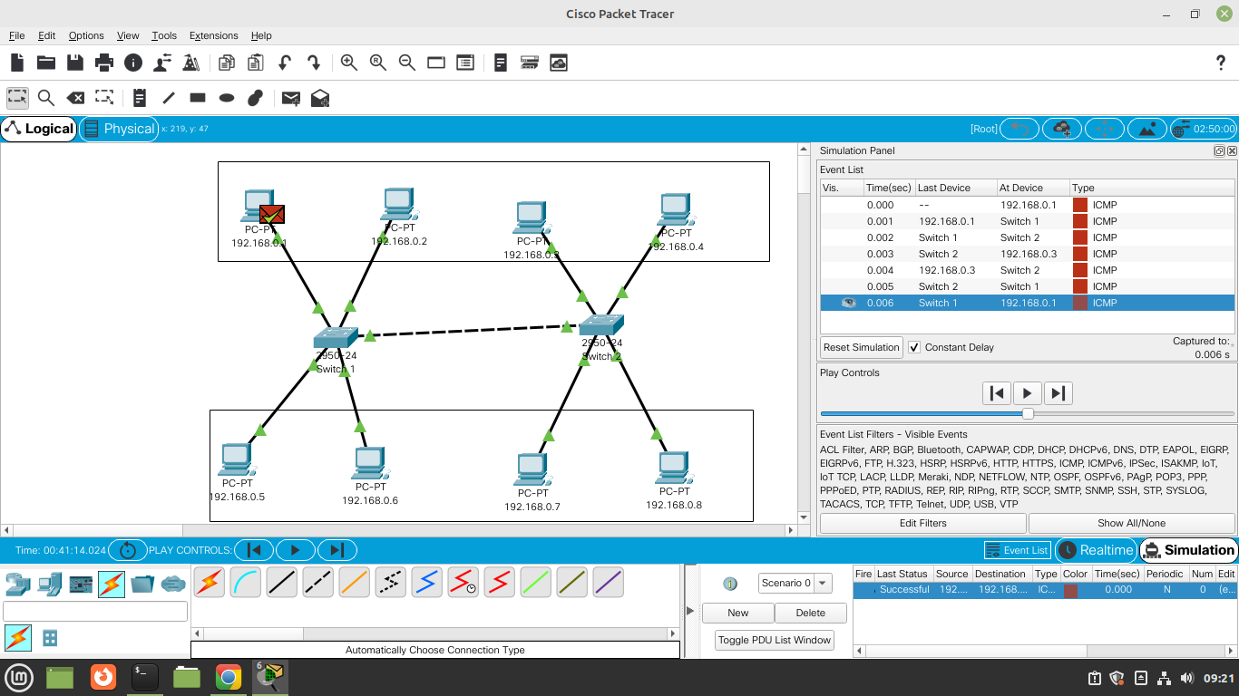

1. **VLAN – 4 (Database) :**

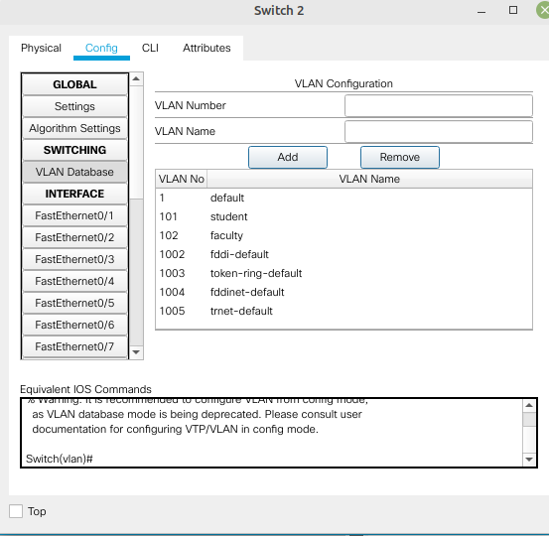

1. **VLAN – 4(PDU Information) :**

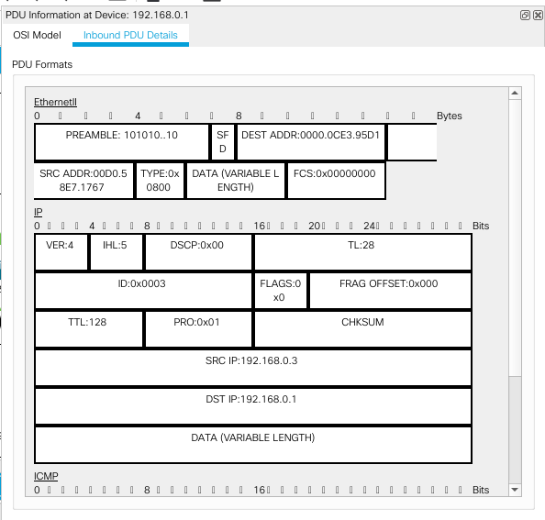

**Lab Practical #06:**

Study the application layer protocol DNS, DHCP, FTP.

**Practical Assignment #06:**

1. **Implement the application layer protocol DNS, DHCP, and FTP. Also check connectivity between them using ping command or PDU utility.**

# DNS – Protocol Configuration :

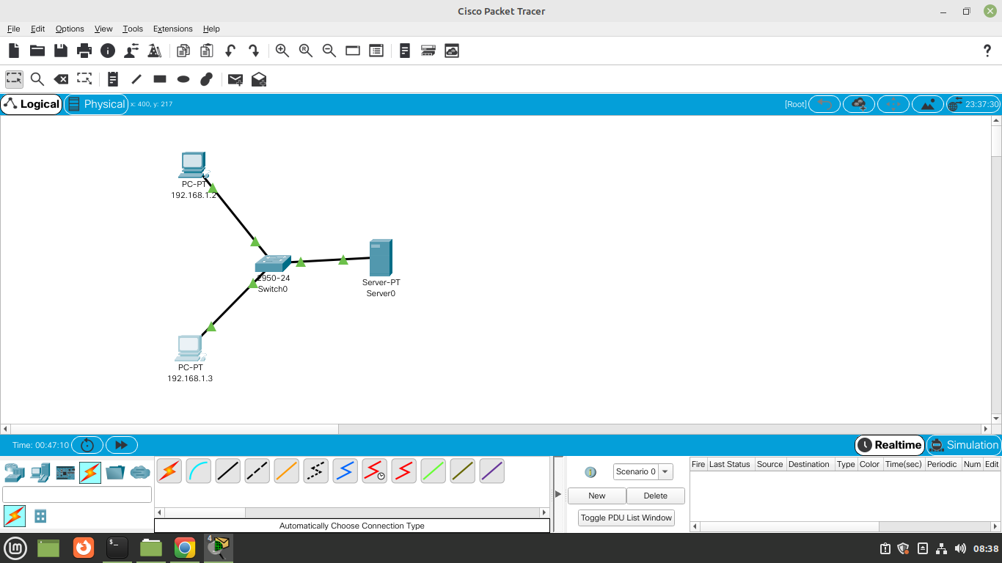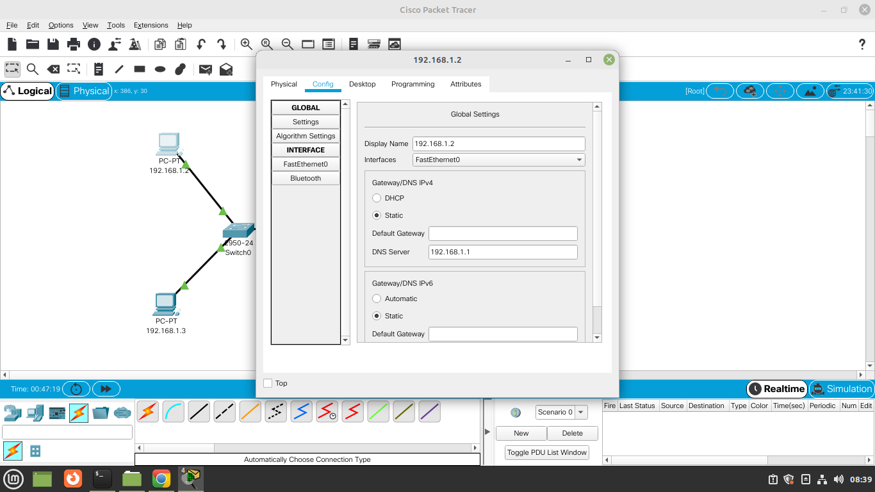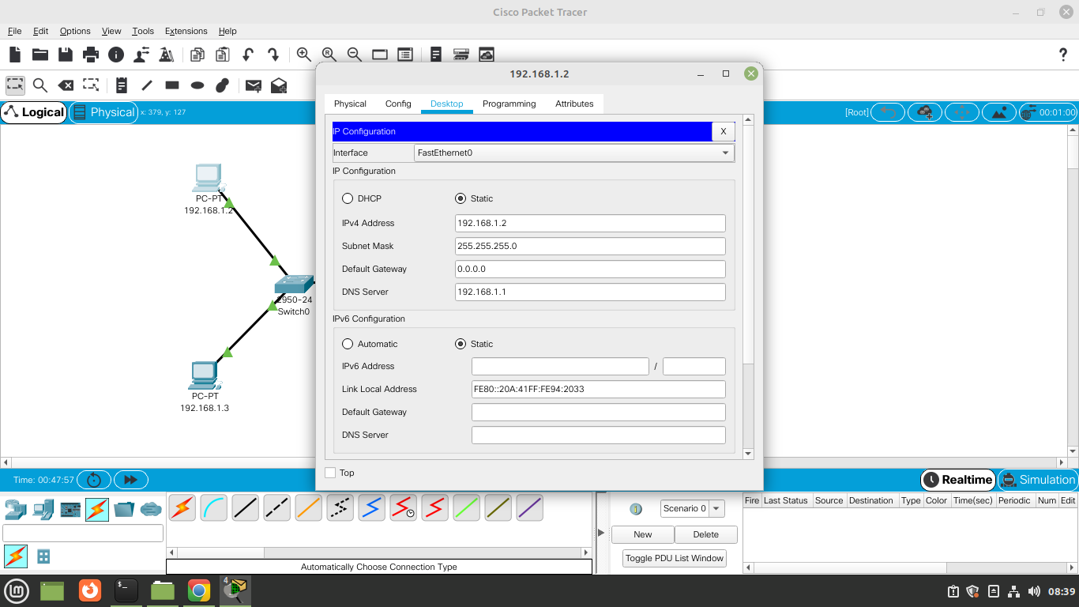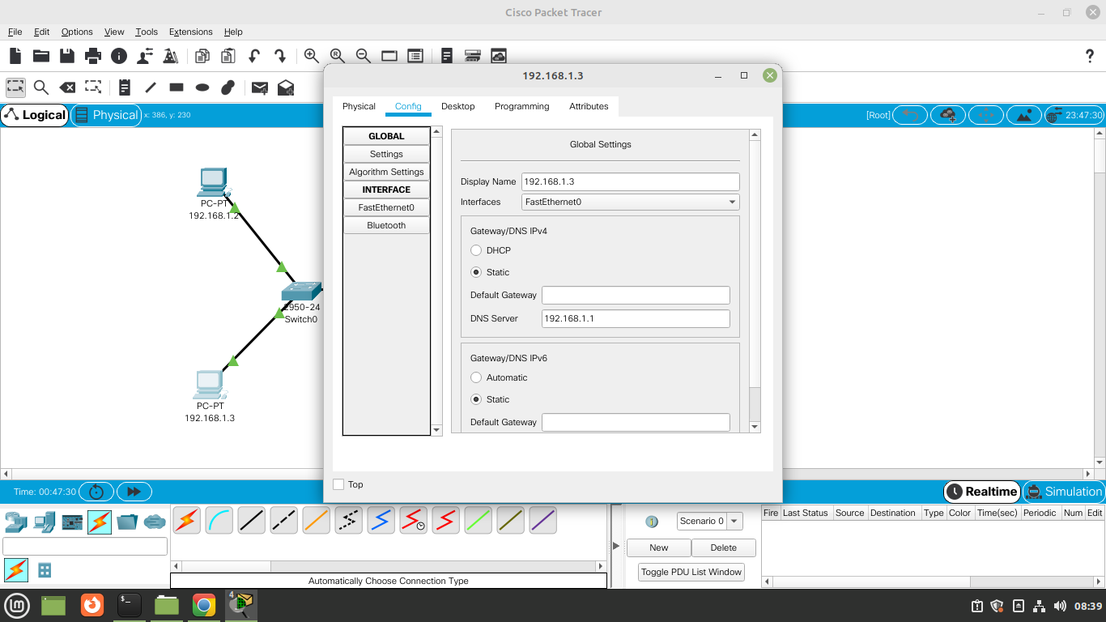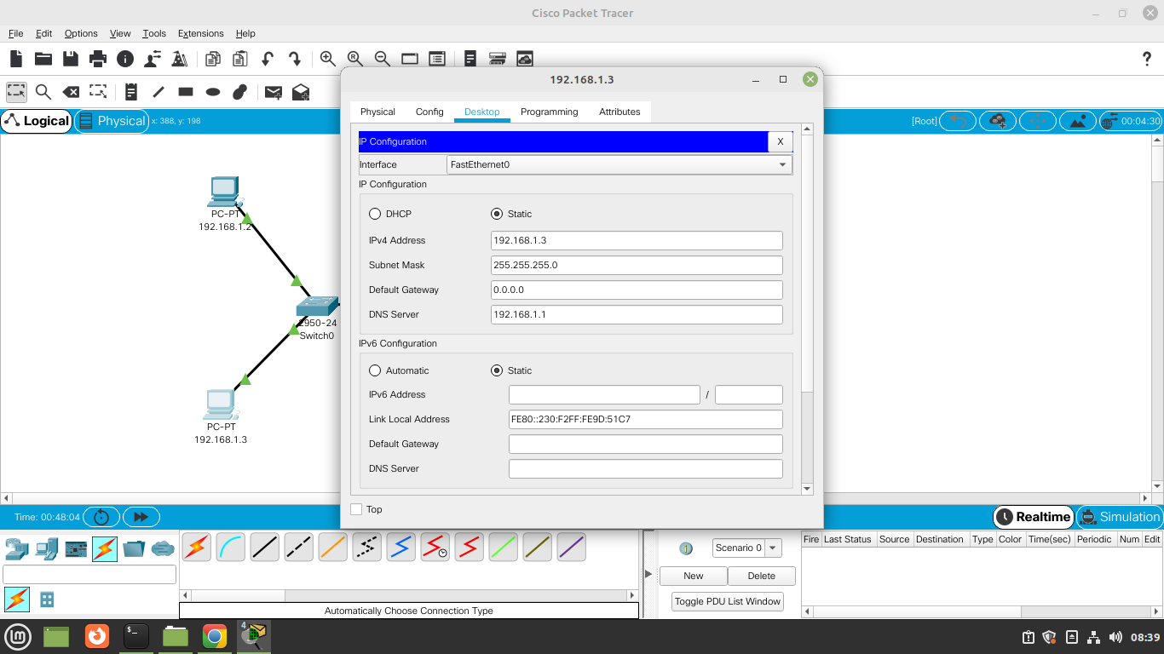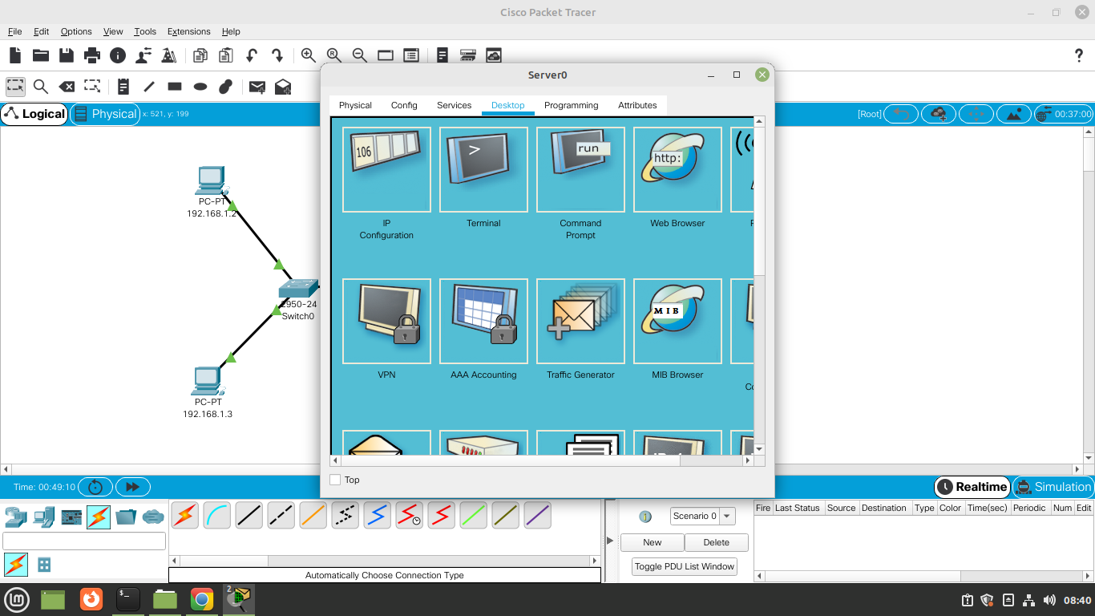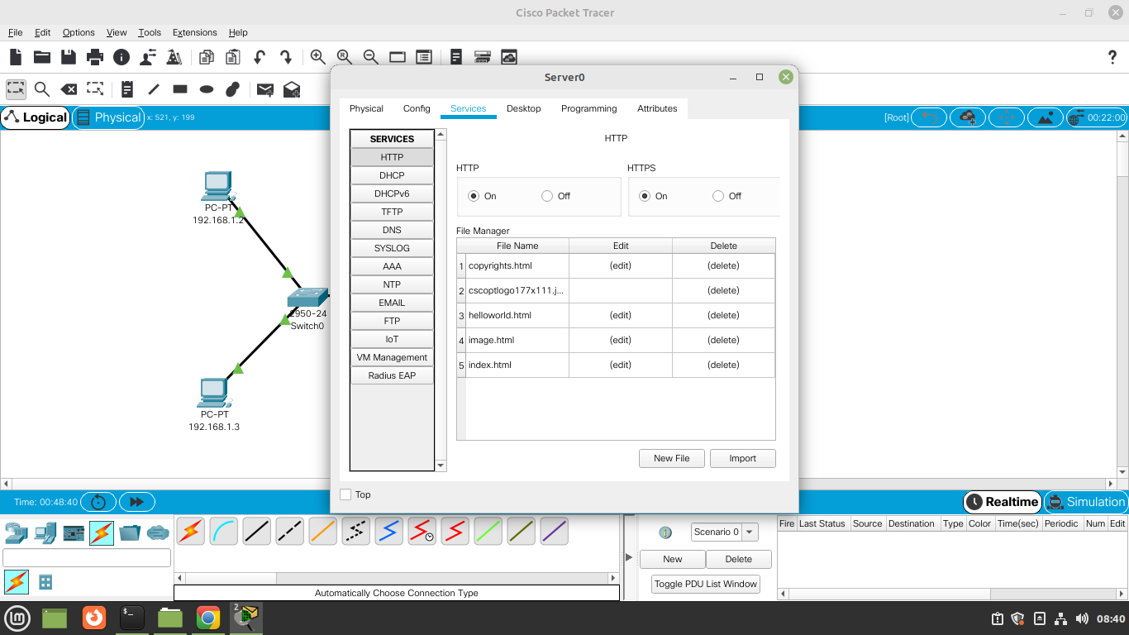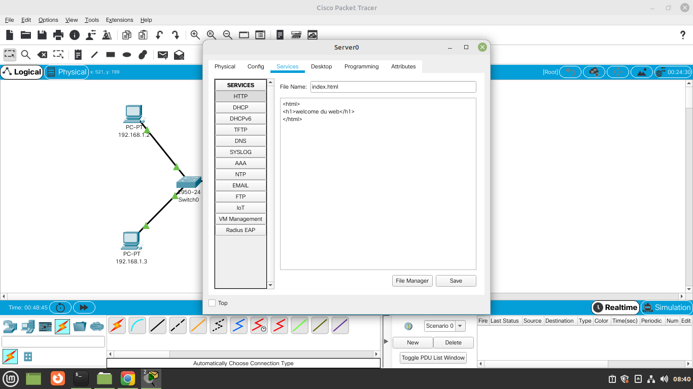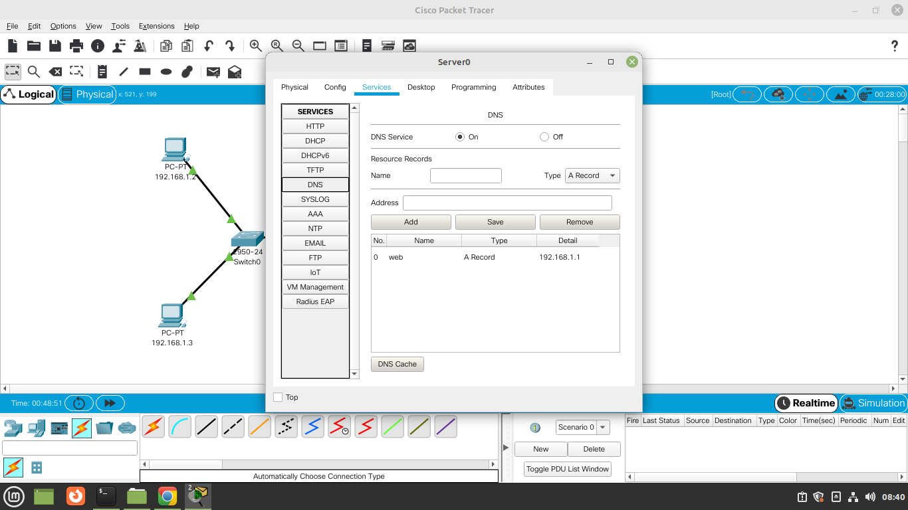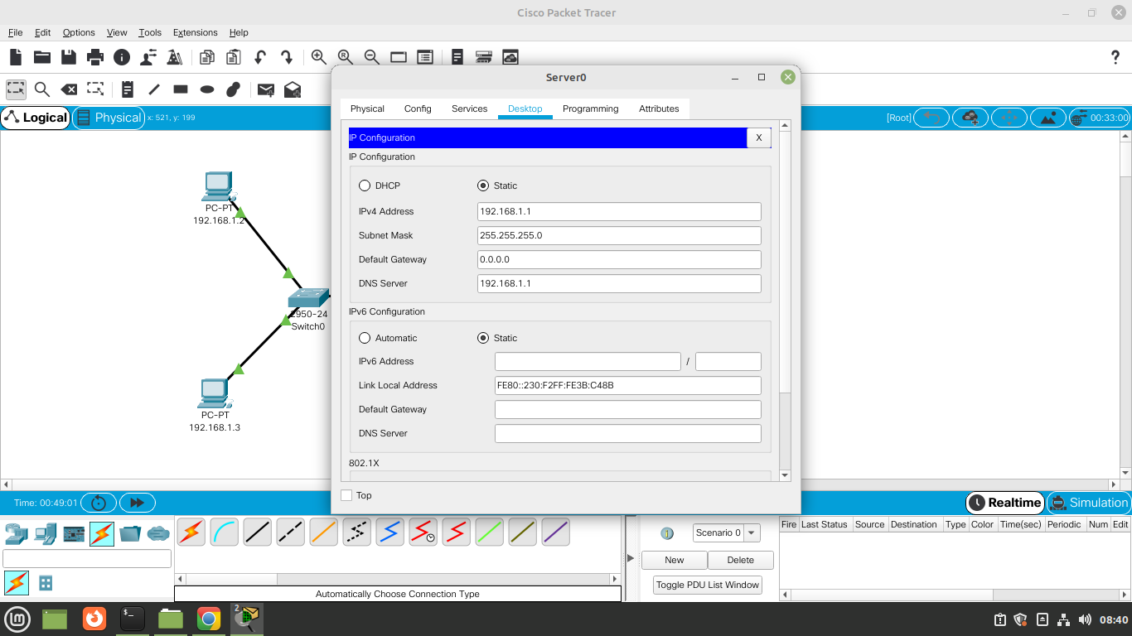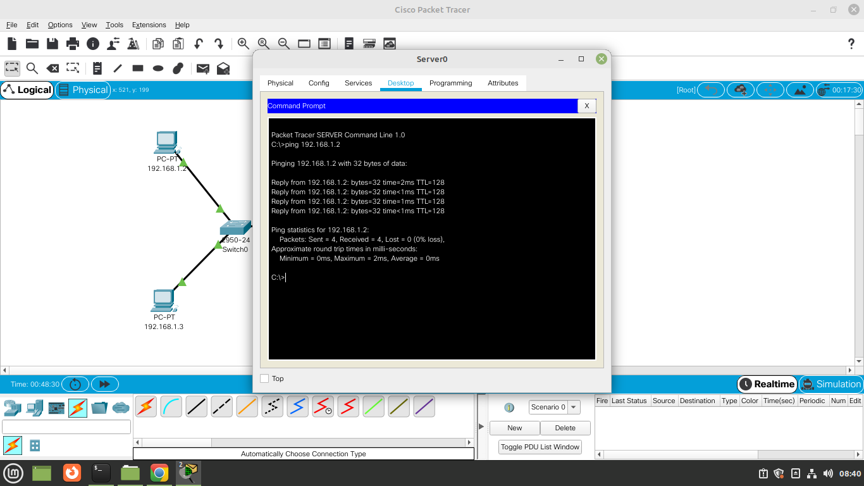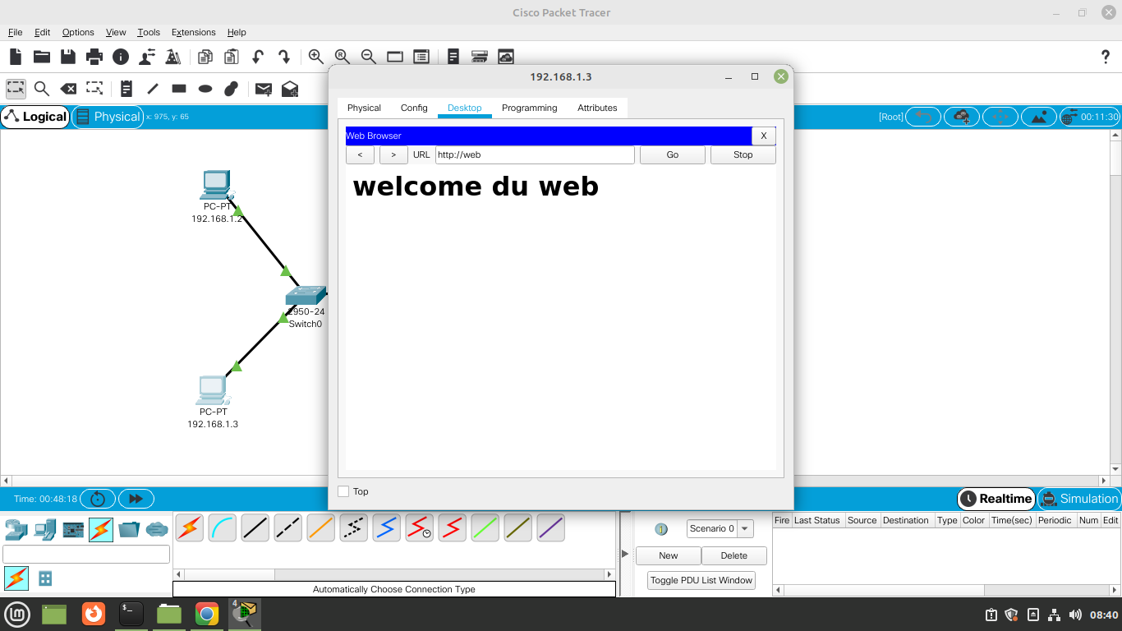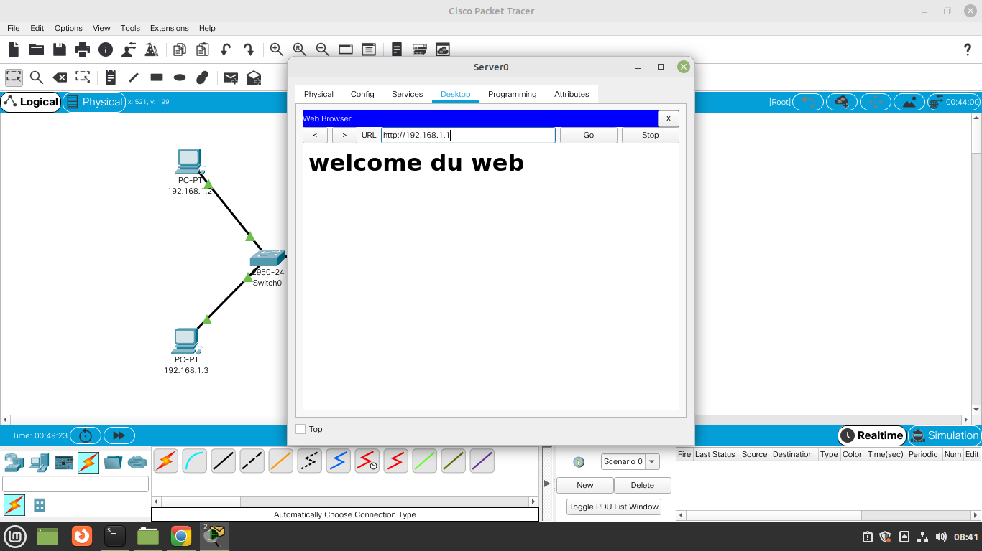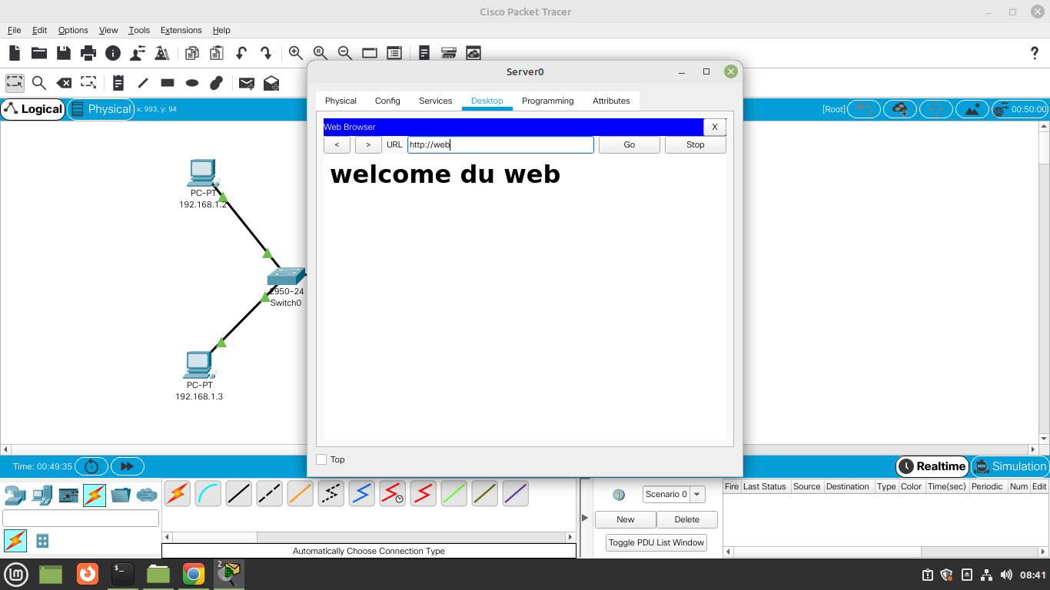

# DHCP Configuration :

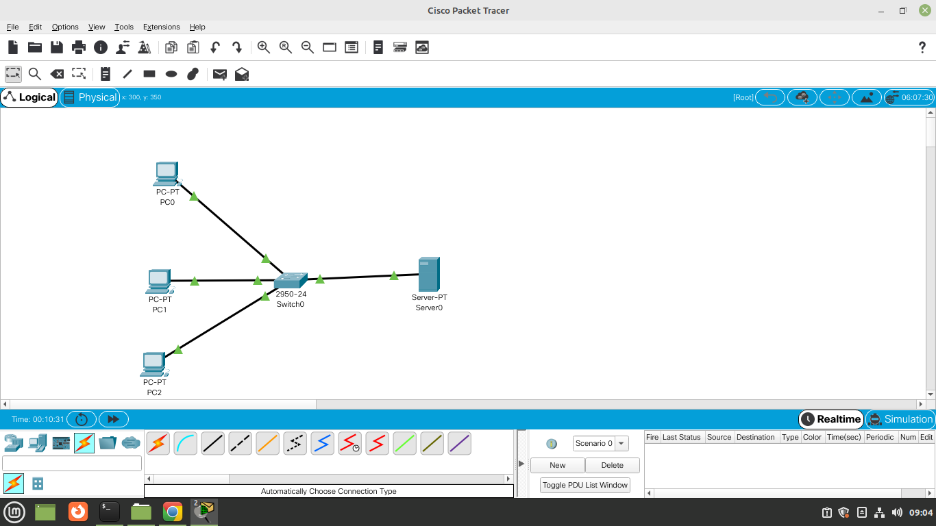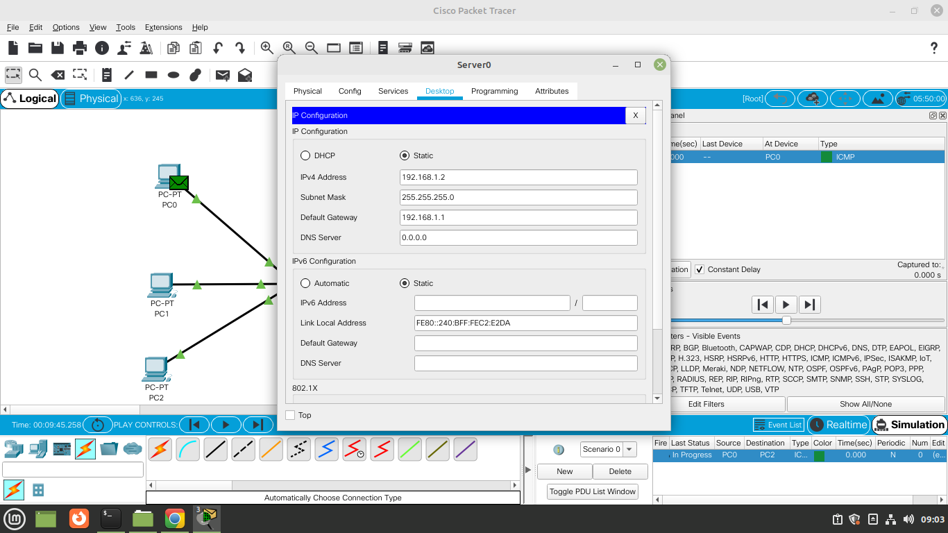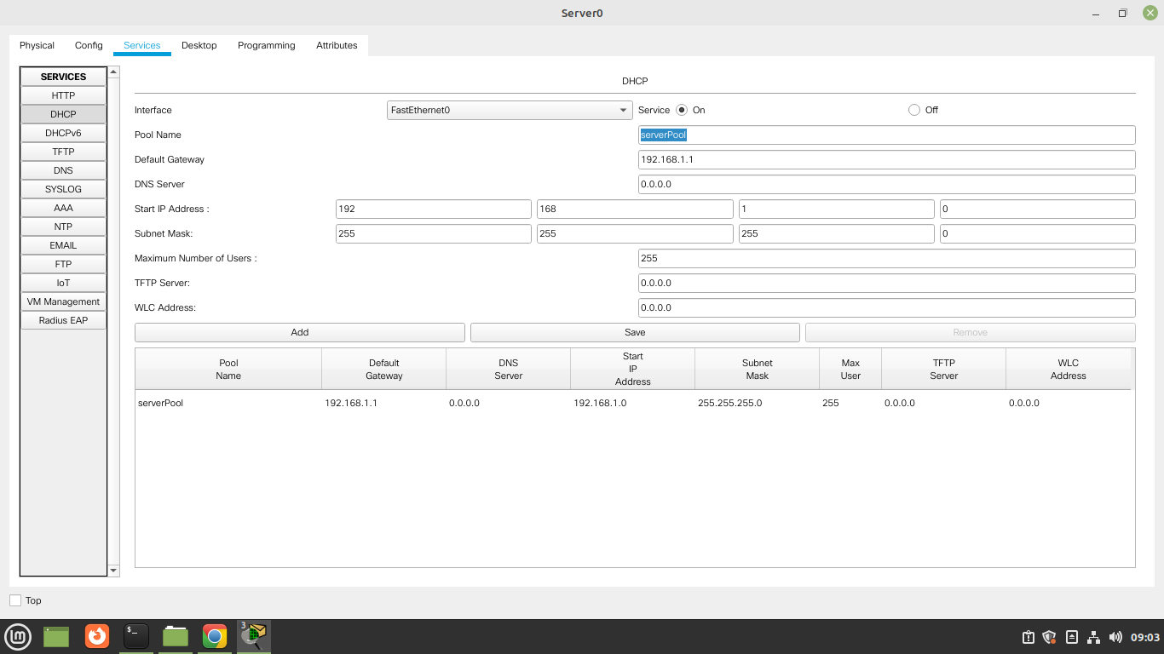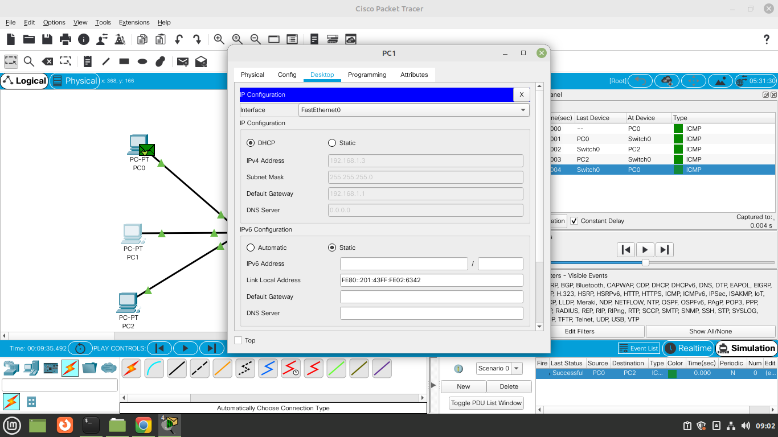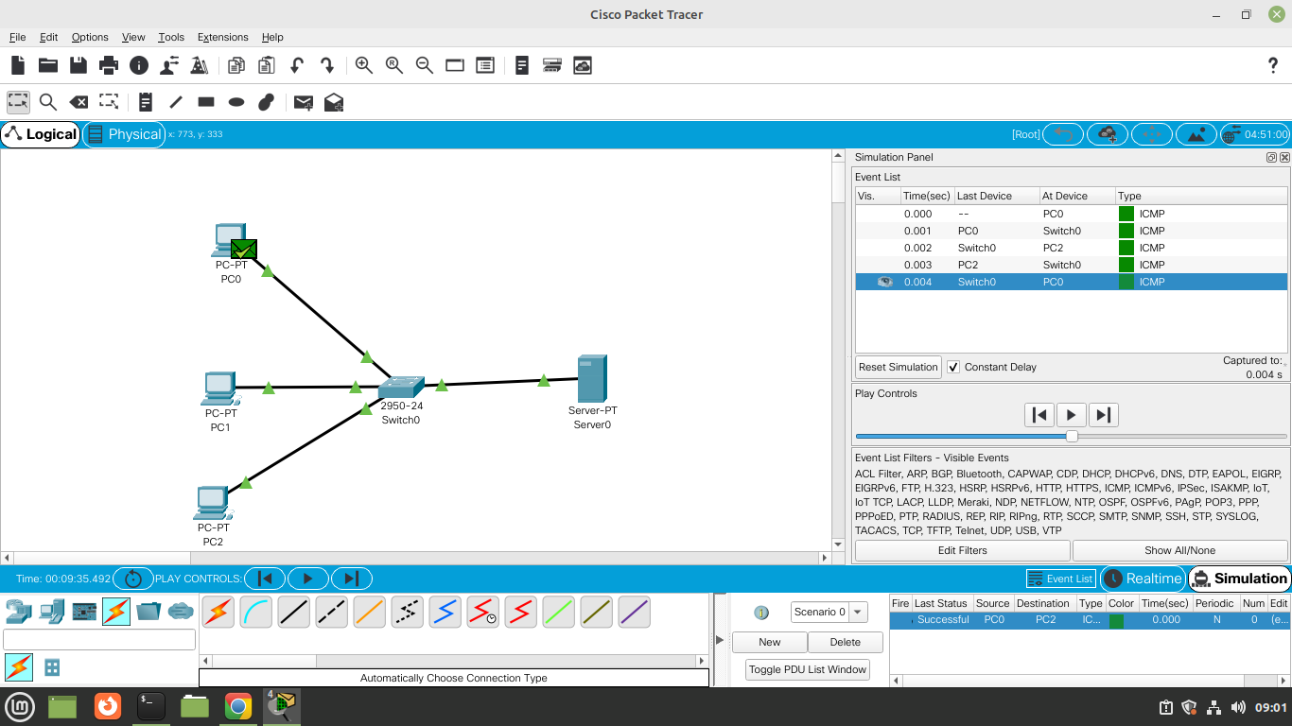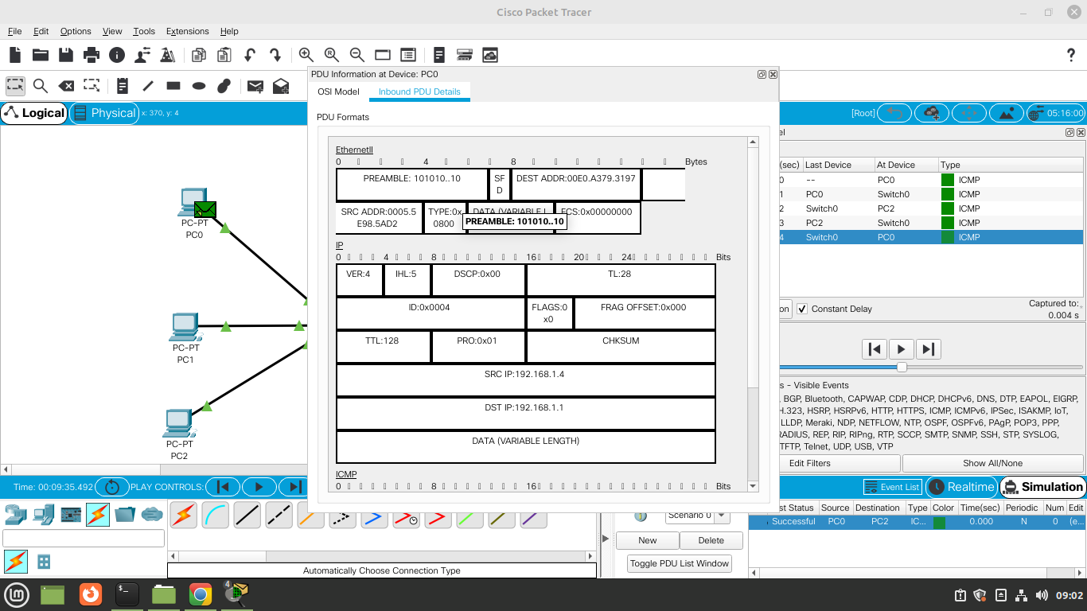

# FTP Configuration :

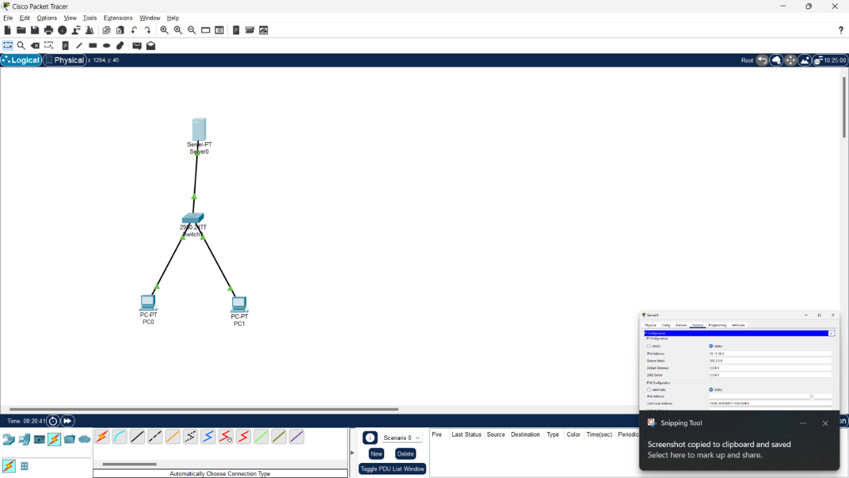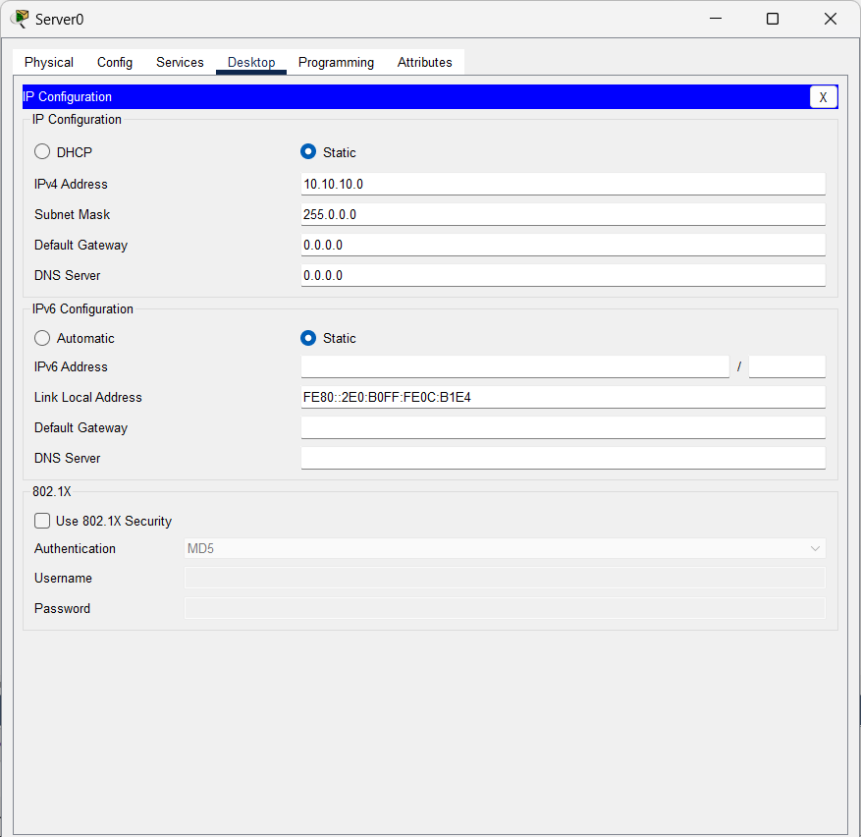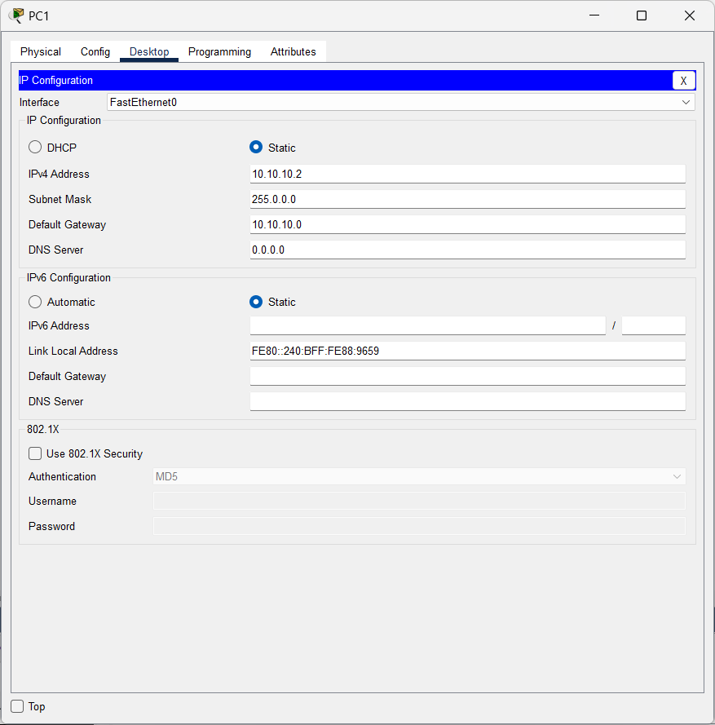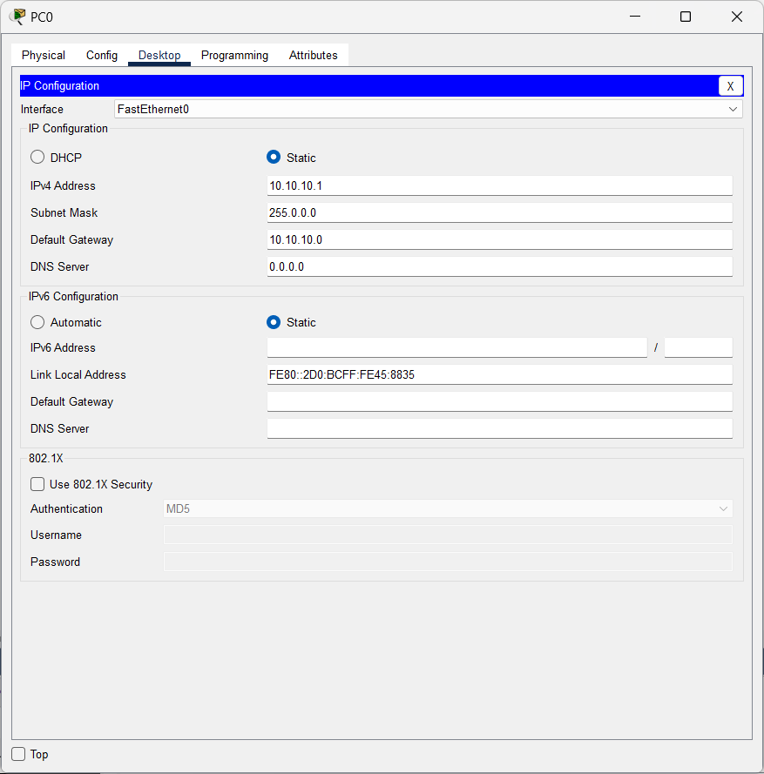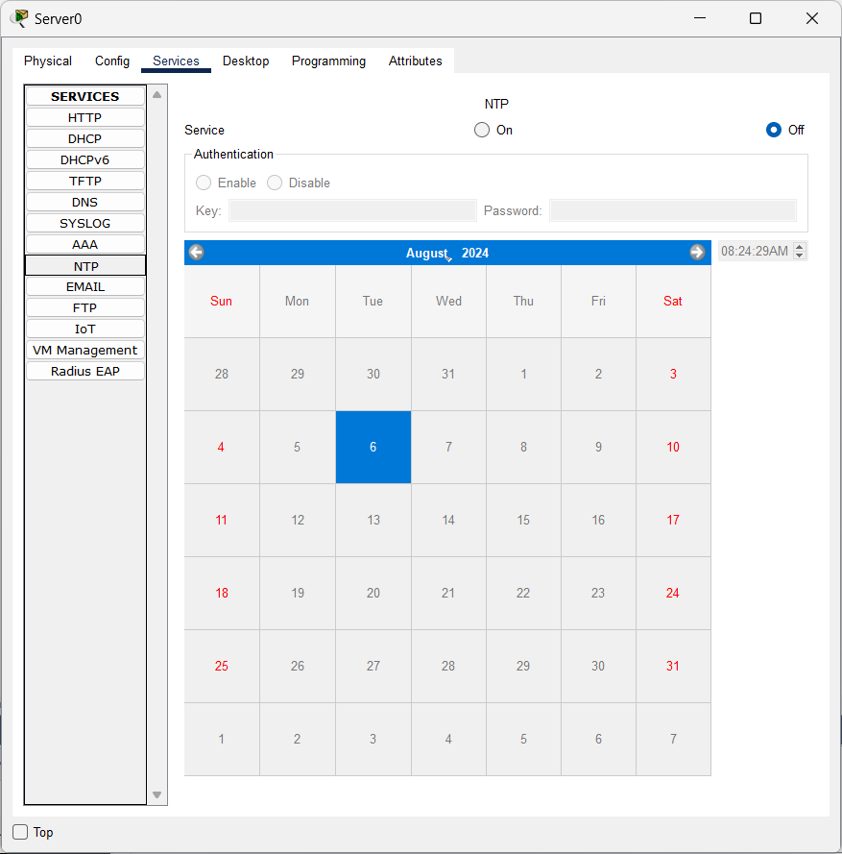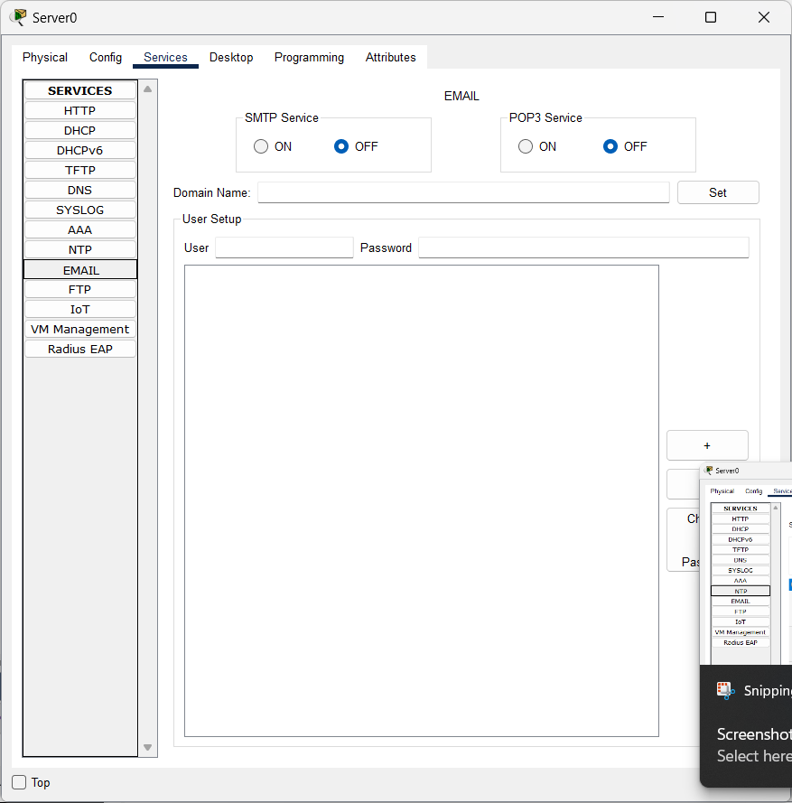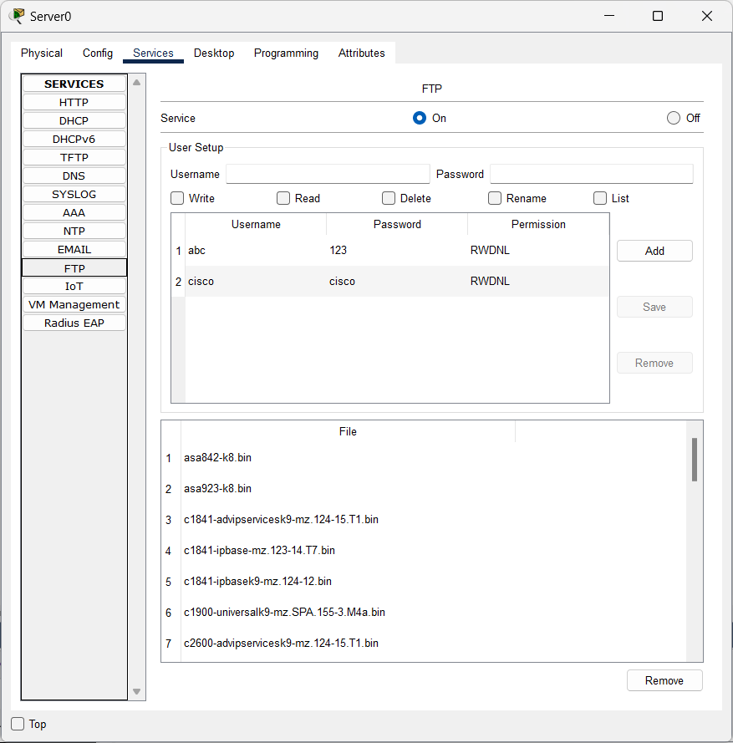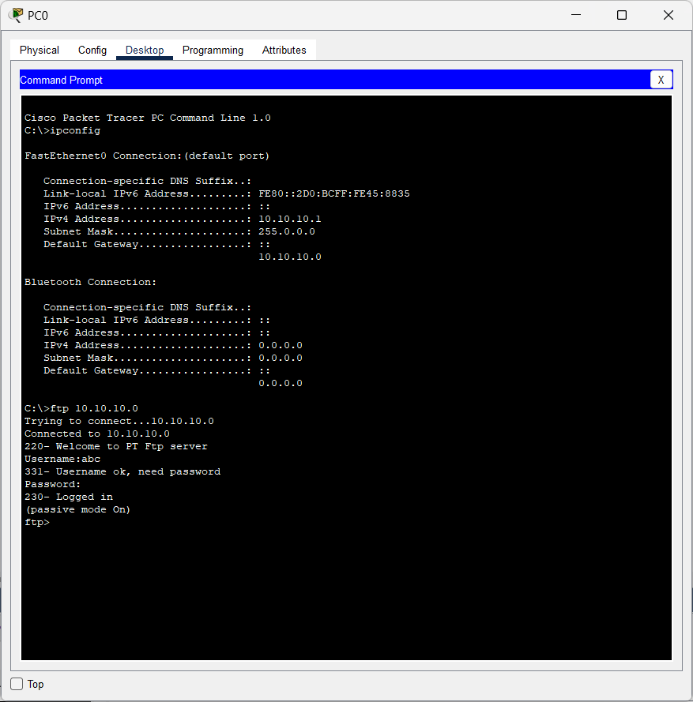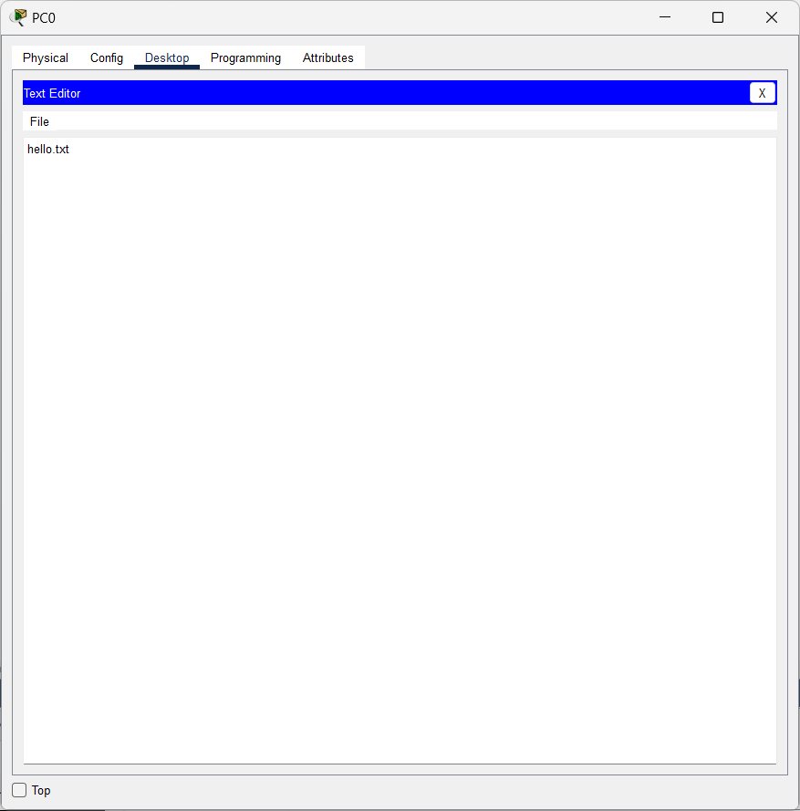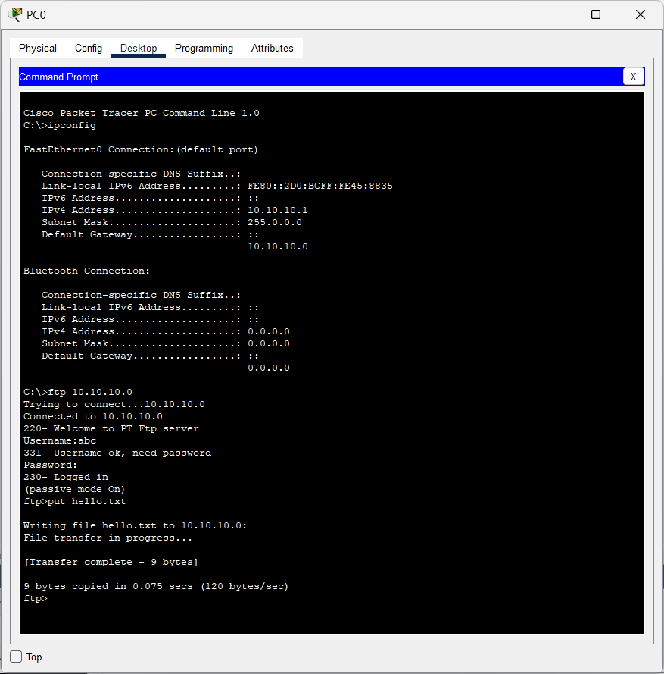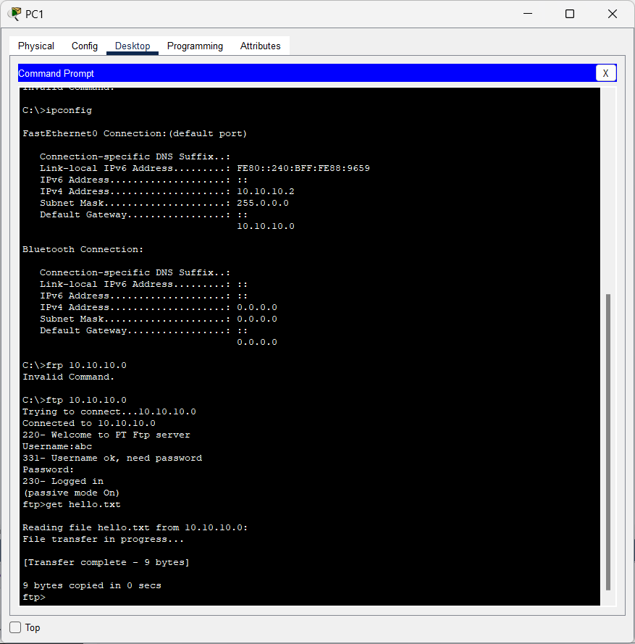

**Lab Practical #07**

Study Client-Server Socket programming - TCP & UDP

**Practical Assignment #07:**

1. **Write a C/Java code for TCP Server-Client Socket Programming.**
2. **Write a C/Java code for UDP Server-Client Socket Programming.**
3. **For TCP Server-Client:**

**TCP Server Program:**

import java.io.BufferedInputStream;

import java.io.DataInputStream;

import java.net.*;

import java.io.*;

public class Server {

    private Socket socket = null;

    private ServerSocket server = null;

    private DataInputStream in = null;

    public Server (int port) {

        //starts server and waits for a connection

        try {

            server = new ServerSocket(port);

            System.out.println("Server started...");

            System.out.println("Waiting for a client...");

            socket = server.accept();

            System.out.println("Client accepted");

            //takes input from the client socket

            in = new DataInputStream(new BufferedInputStream(socket.getInputStream()));

            String line = "";

            // reads message from client until "Over" is sent

            while(!line.equals("Over")) {

                try {

                    line = in.readUTF();

                    System.out.println(line);

                } catch(IOException e) {

                    System.out.println(e);

                }

            }

            System.out.println("Closing connection");

            //close connection

            socket.close();

            in.close();

        }

        catch(IOException e) {

            System.out.println(e);

        }

    }

    public static void main(String args[]) {

        Server server = new Server(5000);

    }

}

**TCP Client Program:**

import java.net.*;

import java.io.*;

public class Client1

{

    //initialize socket and i/o stream

    private Socket socket = null;

    private BufferedReader input = null;

    private DataOutputStream out = null;

    //constructor to put IP address and port

    public Client1(String address, int port) {

        //establish a connection

        try{

            socket = new Socket(address, port);

            System.out.println("Connnected");

            //take input from terminal

            input = new BufferedReader(new InputStreamReader(System.in));

            //sends output to the socket

            out = new DataOutputStream(socket.getOutputStream());

        }

        catch(UnknownHostException e) {

            System.out.println("unknownHost :: " + e);

        }

        catch(IOException e) {

            System.out.println("ioException :: " + e);

        }

        //String to read message from input tab

        String line = "";

        while(!line.equals("Over")) {

            try{

                line = input.readLine();

                out.writeUTF(line);

            }

            catch(IOException e) {

                System.out.println("ioException :: " + e);

            }

        }

        //close the connection

        try {

            input.close();

            out.close();

            socket.close();

        } catch(IOException e) {

            System.out.println("ioException :: " + e);

        }

    }

    public static void main(String args[]) {

        Client1 client = new Client1("127.0.0.1",5000);

    }

}

1. **For UDP Server-Client:**

**UDP Server Program:**

import java.io.IOException;

import java.net.DatagramPacket;

import java.net.DatagramSocket;

import java.net.InetAddress;

import java.net.SocketException;

public class udpBaseServer_2

{

    public static void main(String[] args) throws IOException

    {

        // Step 1 : Create a socket to listen at port 1234

        DatagramSocket ds = new DatagramSocket(1234);

        byte[] receive = new byte[65535];

        DatagramPacket DpReceive = null;

        while (true)

        {

            // Step 2 : create a DatgramPacket to receive the data.

            DpReceive = new DatagramPacket(receive, receive.length);

            // Step 3 : revieve the data in byte buffer.

            ds.receive(DpReceive);

            System.out.println("Client:-" + data(receive));

            // Exit the server if the client sends "bye"

            if (data(receive).toString().equals("bye"))

            {

                System.out.println("Client sent bye.....EXITING");

                break;

            }

            // Clear the buffer after every message.

            receive = new byte[65535];

        }

    }

    // A utility method to convert the byte array

    // data into a string representation.

    public static StringBuilder data(byte[] a)

    {

        if (a == null)

            return null;

        StringBuilder ret = new StringBuilder();

        int i = 0;

        while (a[i] != 0)

        {

            ret.append((char) a[i]);

            i++;

        }

        return ret;

    }

}

**UDP Client Program:**

import java.io.IOException;

import java.net.DatagramPacket;

import java.net.DatagramSocket;

import java.net.InetAddress;

import java.util.Scanner;

public class udpBaseClient_2

{

    public static void main(String args[]) throws IOException

    {

        Scanner sc = new Scanner(System.in);

        // Step 1:Create the socket object for

        // carrying the data.

        DatagramSocket ds = new DatagramSocket();

        InetAddress ip = InetAddress.getLocalHost();

        byte buf[] = null;

        // loop while user not enters "bye"

        while (true)

        {

            String inp = sc.nextLine();

            // convert the String input into the byte array.

            buf = inp.getBytes();

            // Step 2 : Create the datagramPacket for sending

            // the data.

            DatagramPacket DpSend =

                  new DatagramPacket(buf, buf.length, ip, 1234);

            // Step 3 : invoke the send call to actually send

            // the data.

            ds.send(DpSend);

            // break the loop if user enters "bye"

            if (inp.equals("bye"))

                break;

        }

    }

}

**Lab Practical #08:**

Study Packet capture and header analysis by Wireshark (TCP, UDP, IP).

**Practical Assignment #08:**

1. **Explain usage of Wireshark tool.**

Wireshark is a software tool used to monitor the network traffic through a network interface. It is the most widely used network monitoring tool today. Wireshark is loved equally by system administrators, network engineers, network enthusiasts, network security professionals and black hat hackers.

**There are many reasons why Wireshark is so popular :**

1. It has a great GUI as well as a conventional CLI(T Shark).
2. It offers network monitoring on almost all types of network standards (ethernet, wlan, Bluetooth etc)
3. It is open-source with a large community of backers and developers.
4. All the necessary components for monitoring, analyzing and documenting the network traffic are present. It is free to use.
5. **Packet capture and header analysis by Wireshark (TCP, UDP, IP).**

**TCP**

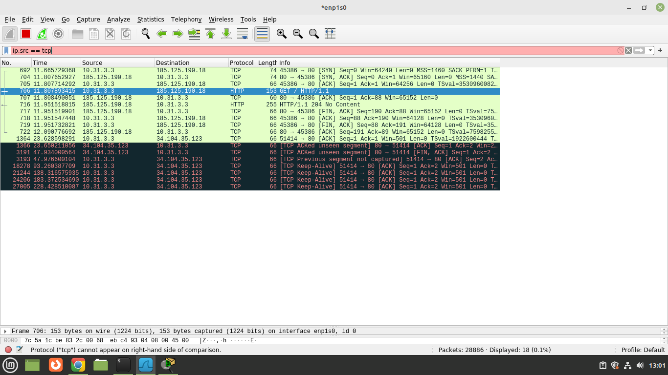

**UDP**

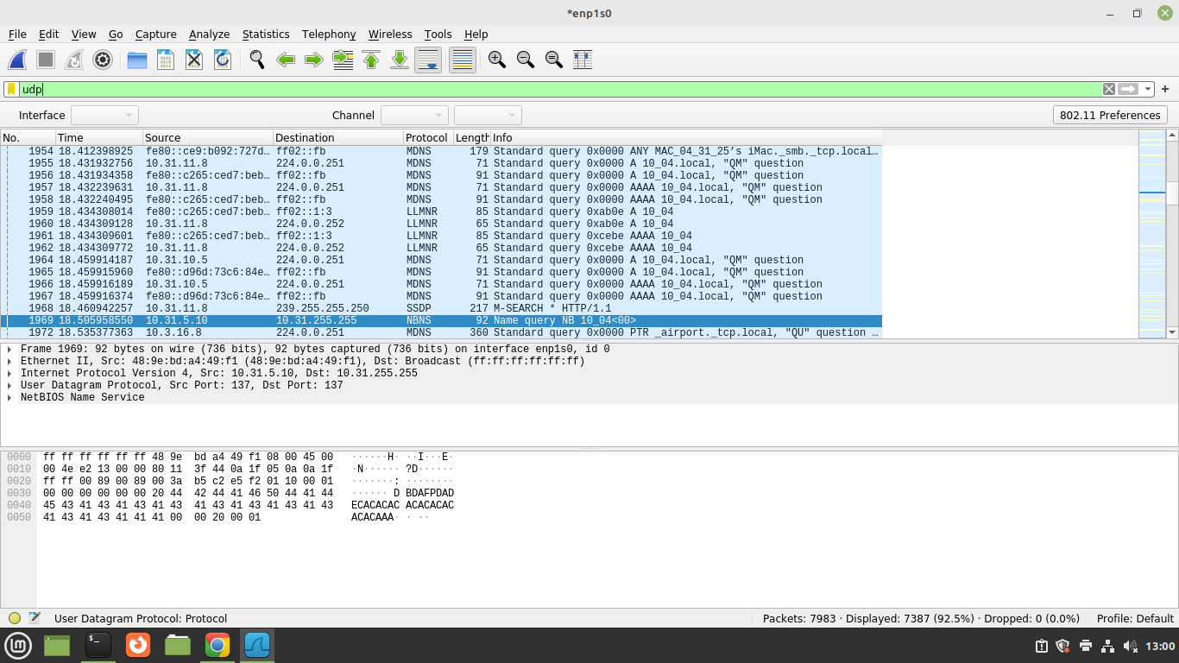

**IP**

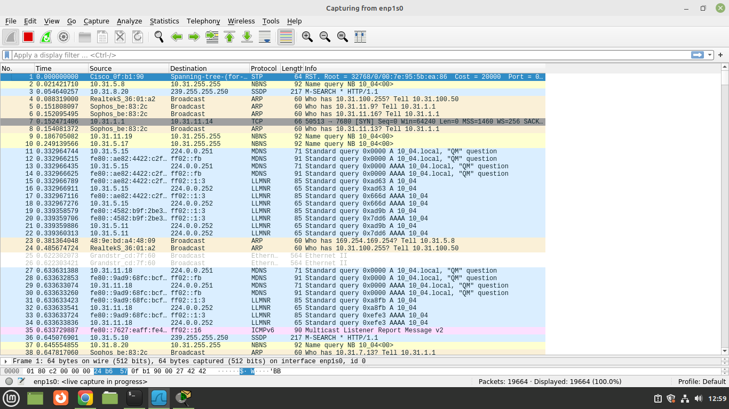

Study of IP Addressing and sub-netting.

**Practical Assignment #09:**

1. Find default subnet marks, network bits, host bits, hosts per subnet, no of subnets, subnet number, 1st valid IP address, last valid IP address, and broadcast address.
   1. 8.1.4.5/16
   2. 130.4.102.1/24
   3. 199.1.1.1/24
   4. 130.4.102.1/22
   5. 199.1.1.100/27

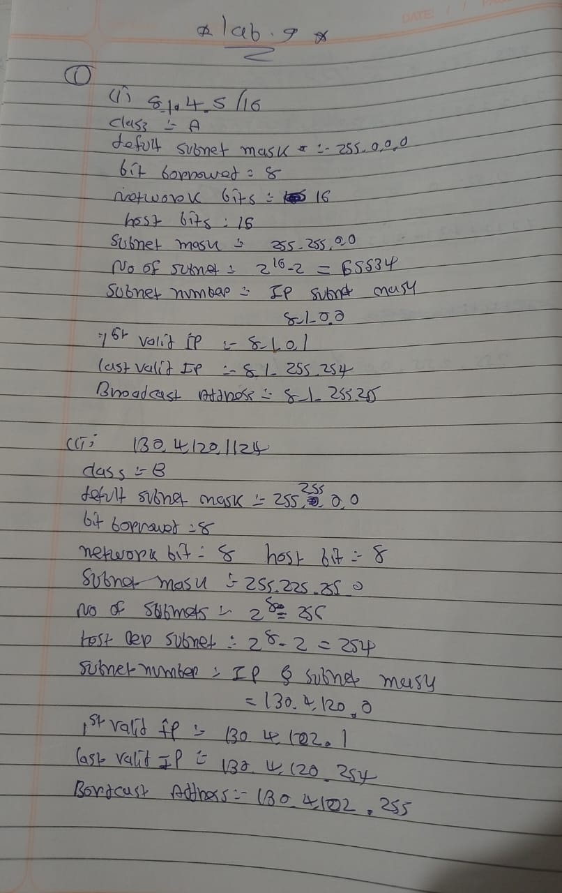

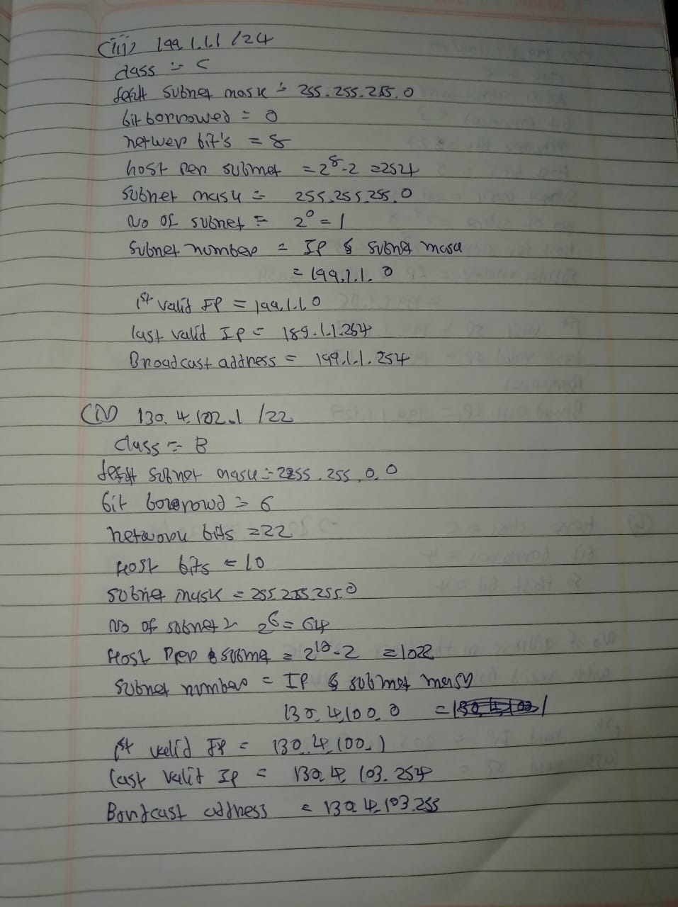

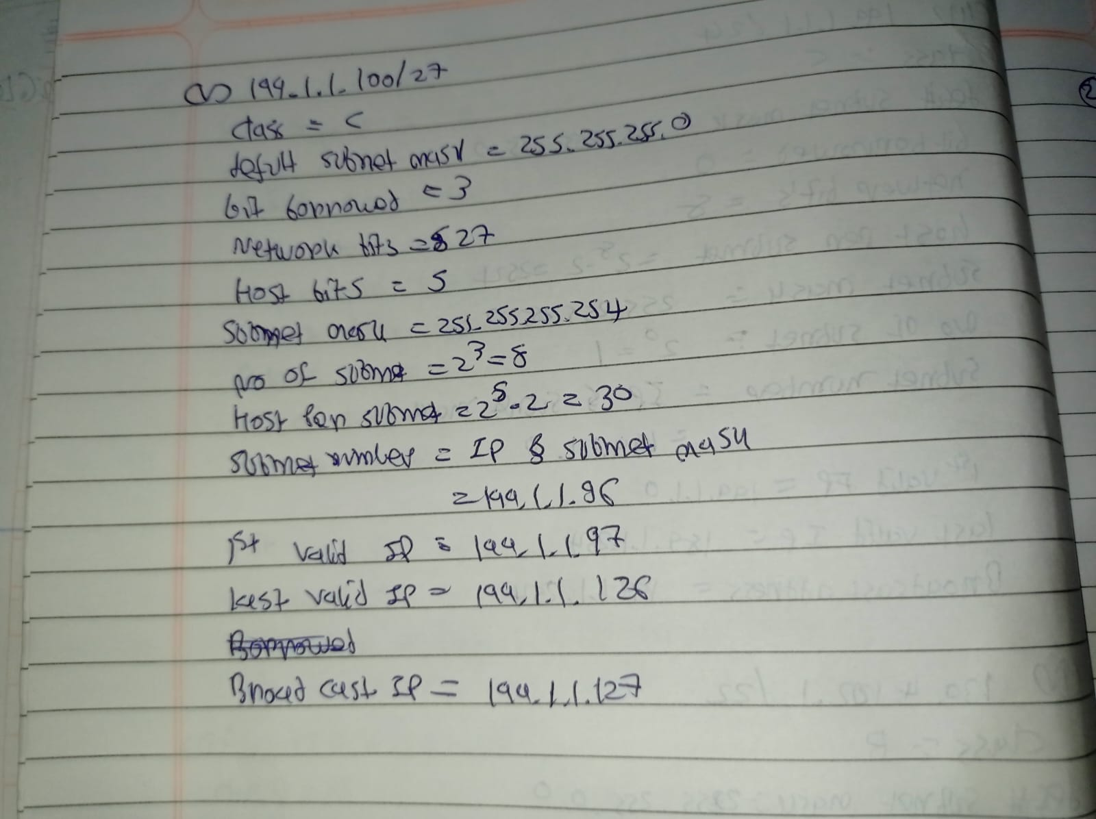

1. A host in a class C network has been assigned an IP address 192.168.17.9. Find the number of addresses in the block, the first address, and the last address.

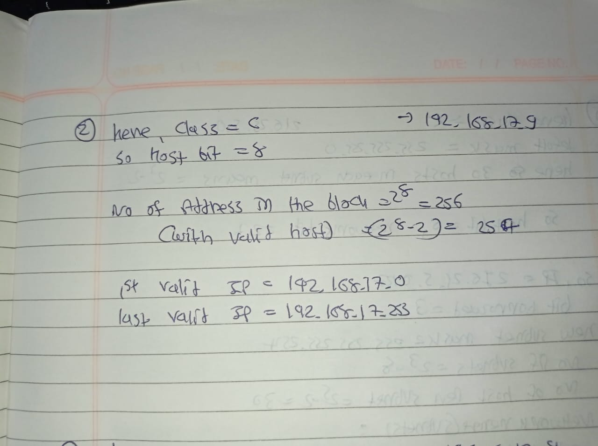

1. An address in a block is given as 185.28.17.9. Find the number of addresses in the block, the first address, and the last address.

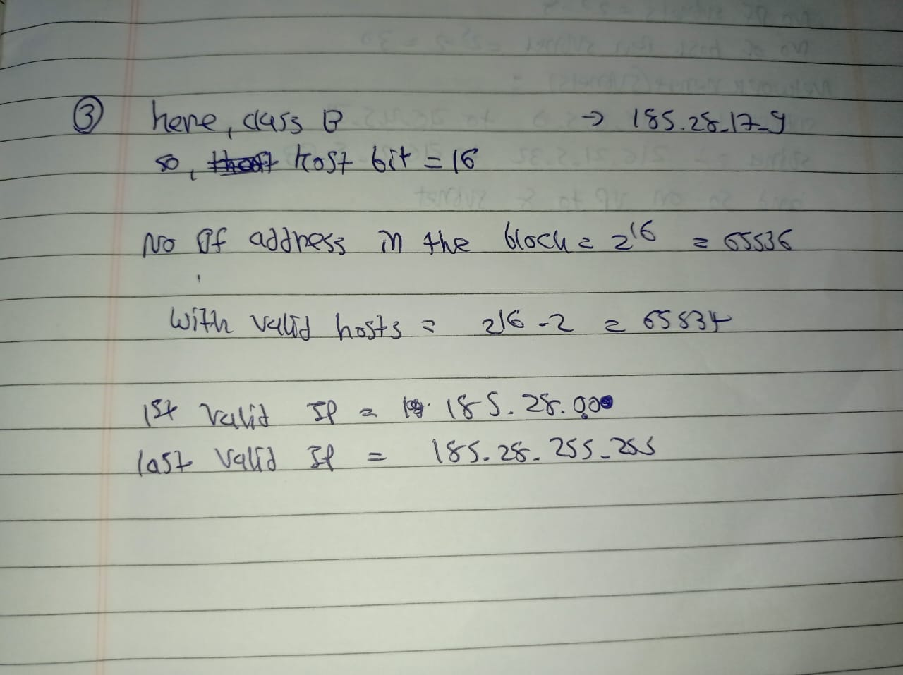

1. A block of addresses is granted to a small organization. We know that one of the addresses is 205.16.37.39/28. What is the first address, last address, number of addresses in a block.

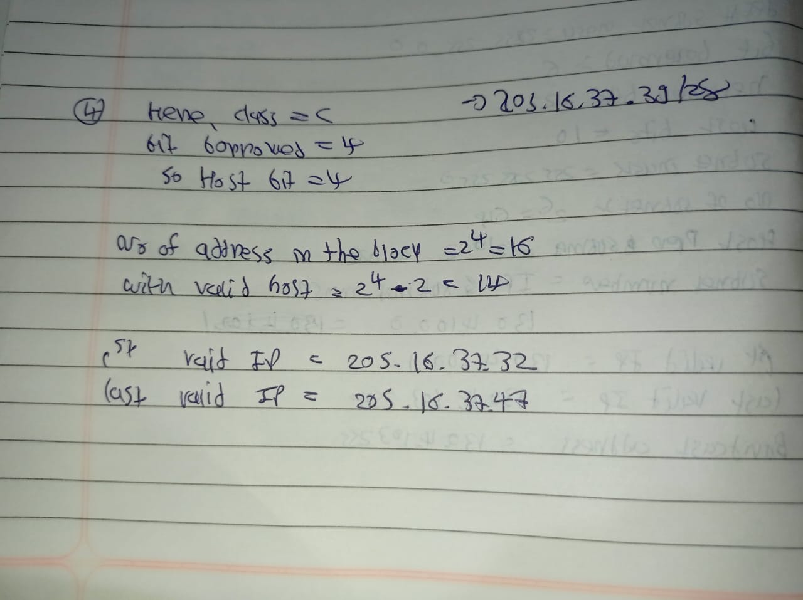

1. Subnet the IP address 216.21.5.0 into 30 hosts in each subnet. Find Class, Default Mask, Bit Borrowed, New subnet mask, No. of Hosts & Subnet, Network Ranges (Subnets).

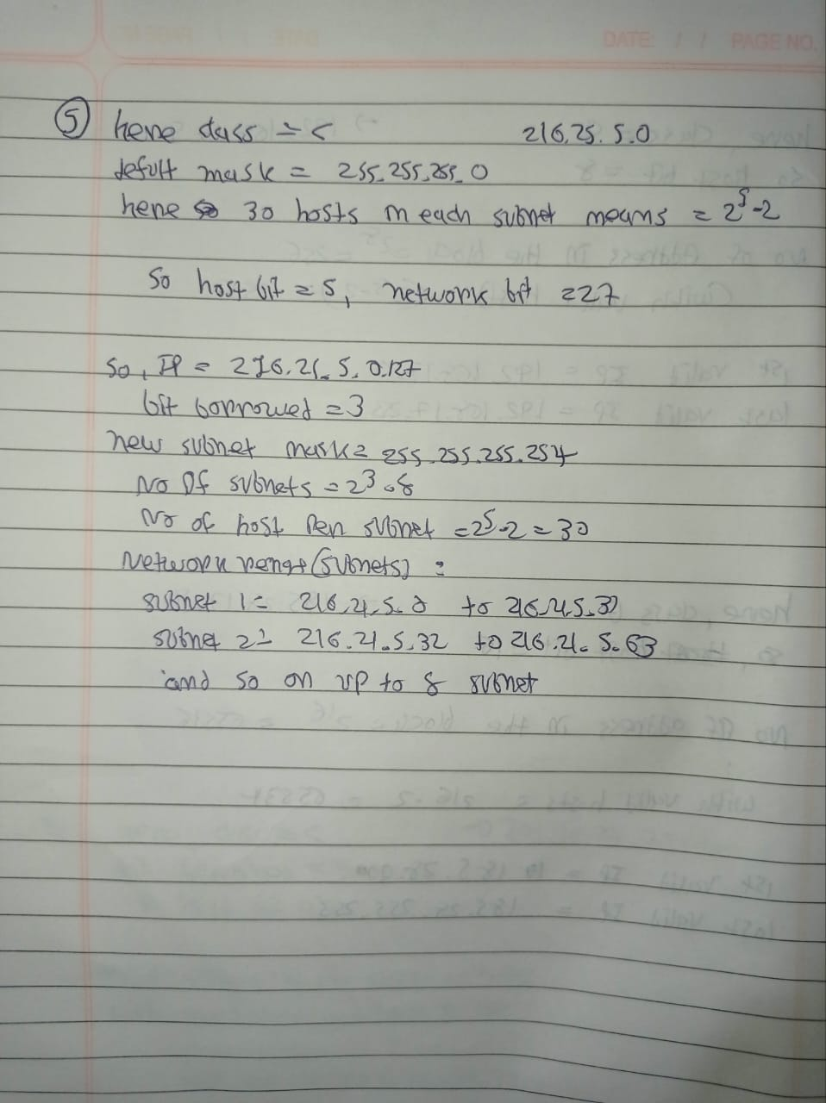

1. Subnet the IP address 192.10.20.0 into 52 hosts in each subnet. Find Class, Default Mask, Bit Borrowed, New subnet mask, No. of Hosts & Subnet, Network Ranges (Subnets).

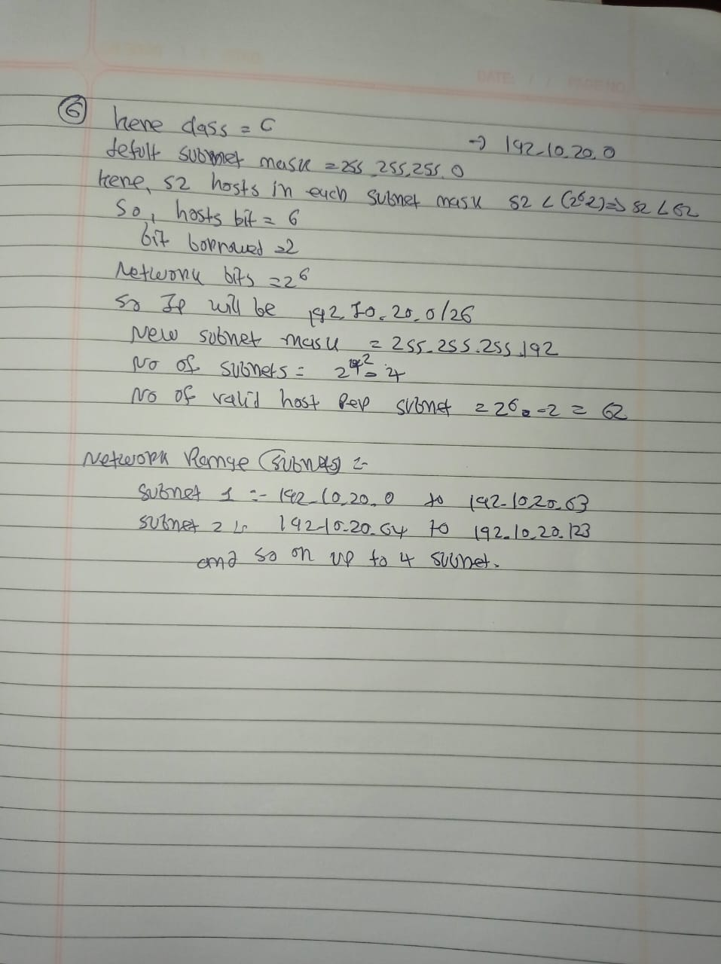

**Lab Practical #10:**

Study the concept of routing using packet tracer. (Static Routing)

**Practical Assignment #10:**

1. Connect the two different networks based on the calculated IP addresses and subnet using a packet tracer.

**Static:**

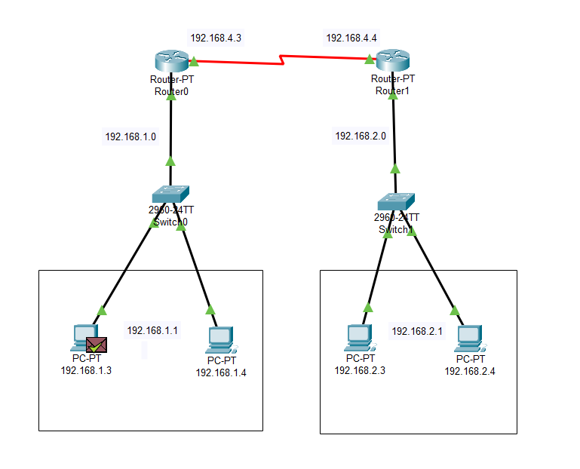

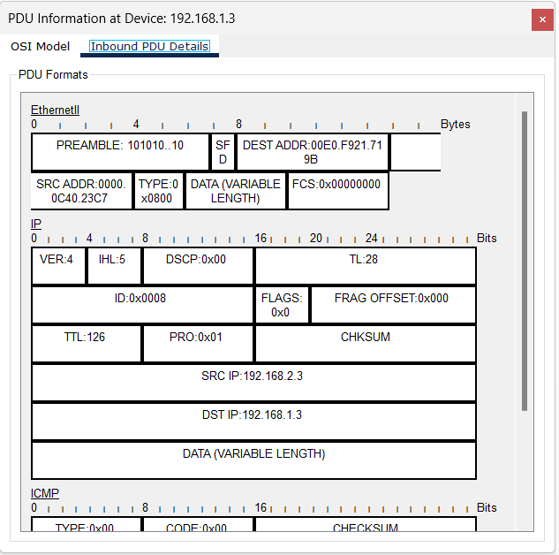

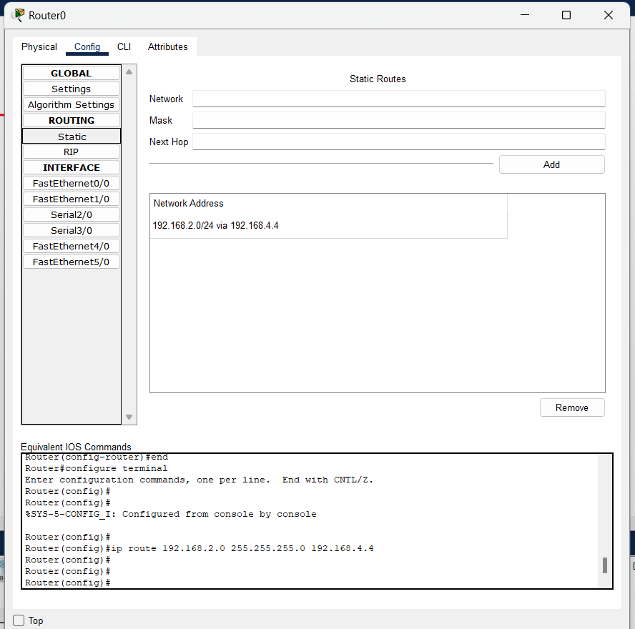

1. Connect the three different networks based on the calculated IP addresses and subnet using a packet tracer.

**Static:**

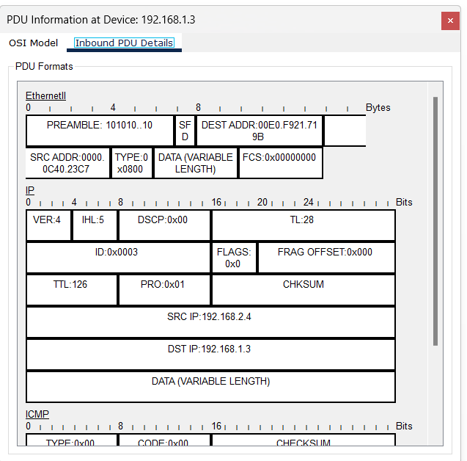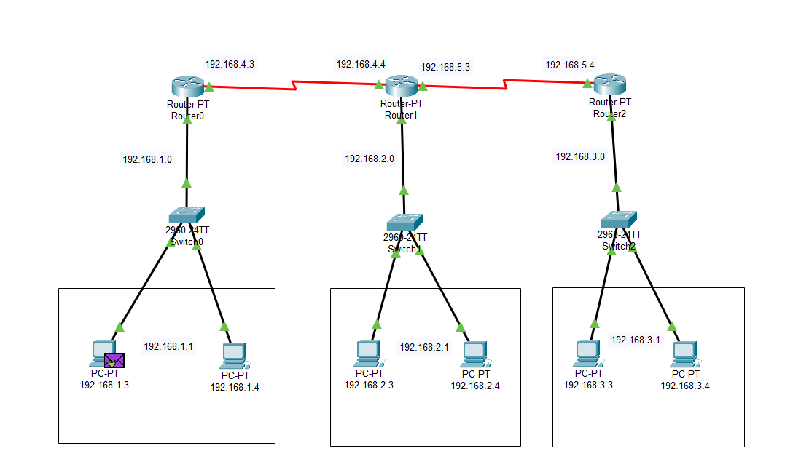

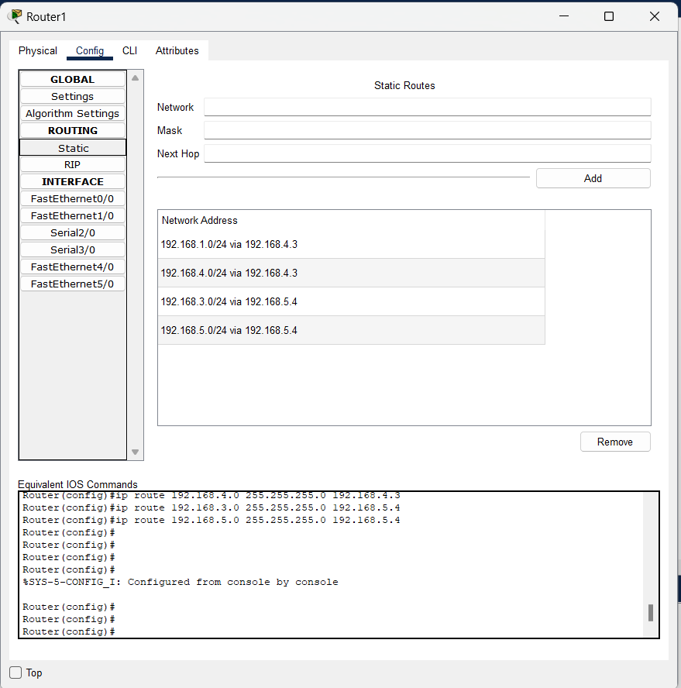

**Lab Practical #11:**

Study the concept of routing using packet tracer. (Dynamic Routing)

**Practical Assignment #11:**

1. Connect the two different networks based on the calculated IP addresses and subnet using a packet tracer.

**Dynamic:**

1. 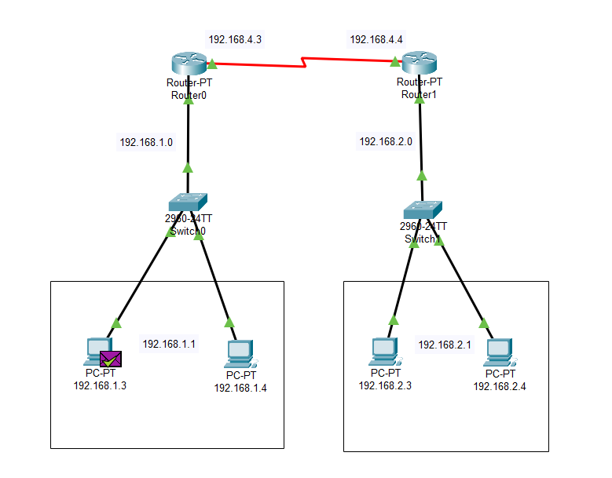
2. 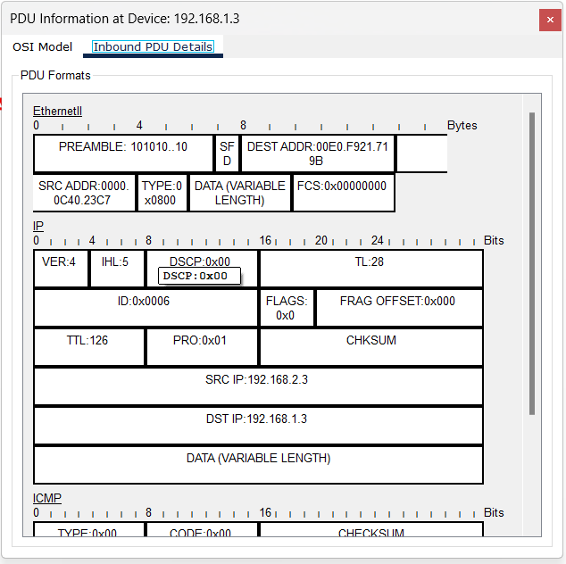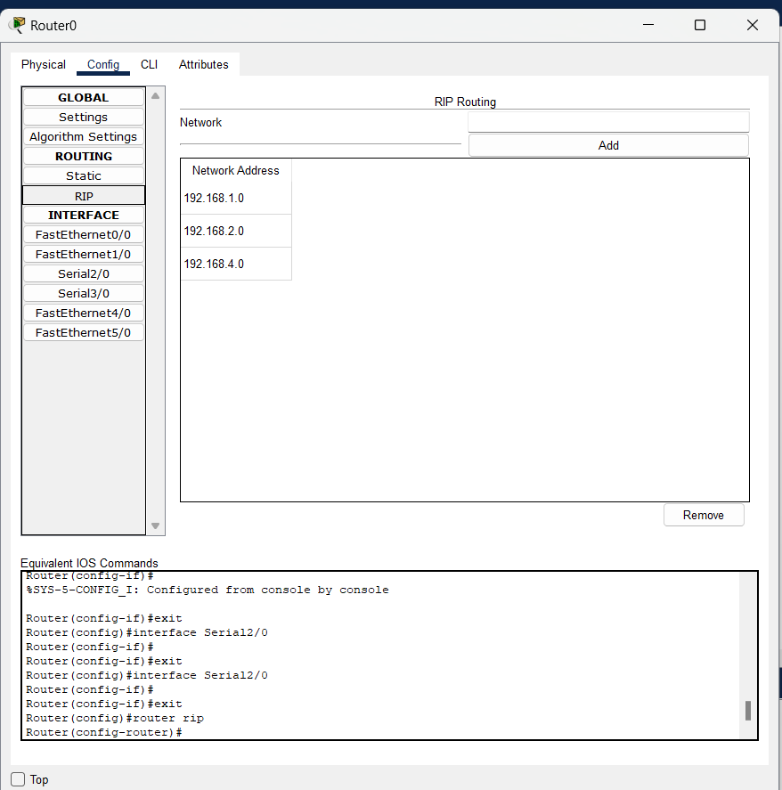
3. Connect the three different networks based on the calculated IP addresses and subnet using a packet tracer.

**Dynamic:**

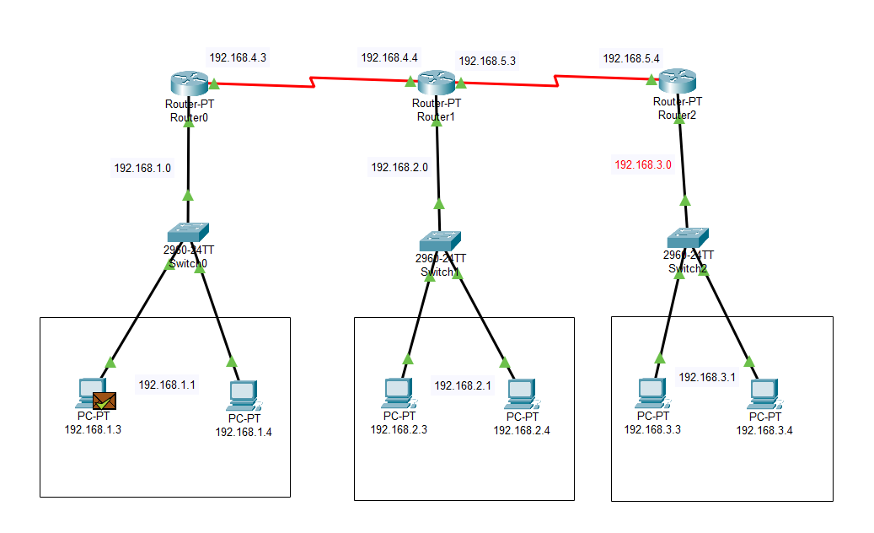

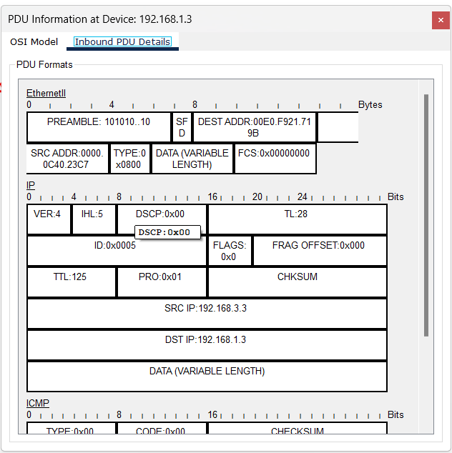

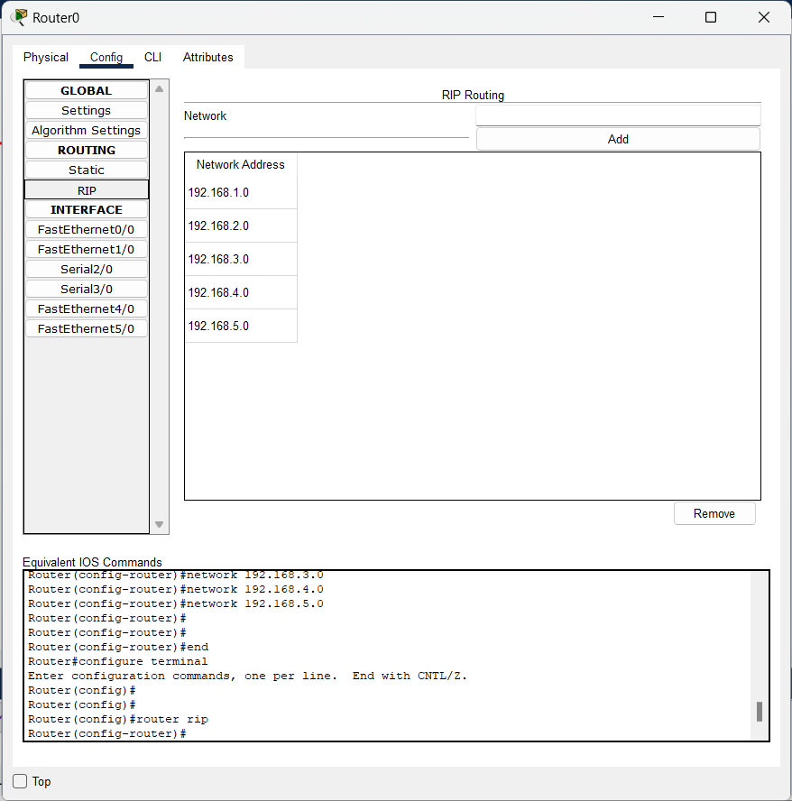

**Lab Practical #12:**

To develop network using distance vector routing protocol and link state routing protocol.

**Practical Assignment #12:**

1. **C/JAVA Program: Distance Vector Routing Algorithm using Bellman Ford's Algorithm.**
2. #include<stdio.h>
3. struct node
4. {
5. unsigned dist[20];
6. unsigned from[20];
7. }rt[10];
8. int main()
9. {
10. int costmat[20][20];
11. int nodes,i,j,k,count=0;
12. printf("\nEnter the number of nodes : ");
13. scanf("%d",&nodes);//Enter the nodes
14. printf("\nEnter the cost matrix :\n");
15. for(i=0;i<nodes;i++)
16. {
17. for(j=0;j<nodes;j++)
18. {
19. scanf("%d",&costmat[i][j]);
20. costmat[i][i]=0;
21. rt[i].dist[j]=costmat[i][j];//initialise the distance equal to cost matrix
22. rt[i].from[j]=j;
23. }
24. }
25. do
26. {
27. count=0;
28. for(i=0;i<nodes;i++)//We choose arbitary vertex k and we calculate the direct distance from the node i to k using the cost matrix
29. //and add the distance from k to node j
30. for(j=0;j<nodes;j++)
31. for(k=0;k<nodes;k++)
32. if(rt[i].dist[j]>costmat[i][k]+rt[k].dist[j])
33. {//We calculate the minimum distance
34. rt[i].dist[j]=rt[i].dist[k]+rt[k].dist[j];
35. rt[i].from[j]=k;
36. count++;
37. }
38. }while(count!=0);
39. for(i=0;i<nodes;i++)
40. {
41. printf("\n\n For router %d\n",i+1);
42. for(j=0;j<nodes;j++)
43. {
44. printf("\t\nnode %d via %d Distance %d ",j+1,rt[i].from[j]+1,rt[i].dist[j]);
45. }
46. }
47. printf("\n\n");
48. getch();
49. }

**2. C/JAVA Program: Link state routing algorithm.**

#include <stdio.h>

#include <string.h>

int main()

{

int count,src_router,i,j,k,w,v,min;

int cost_matrix[100][100],dist[100],last[100];

int flag[100];

 printf("\n Enter the no of routers");

scanf("%d",&count);

printf("\n Enter the cost matrix values:");

for(i=0;i<count;i++)

{

for(j=0;j<count;j++)

{

 printf("\n%d->%d:",i,j);

scanf("%d",&cost_matrix[i][j]);

if(cost_matrix[i][j]<0)cost_matrix[i][j]=1000;

}

}

 printf("\n Enter the source router:");

scanf("%d",&src_router);

for(v=0;v<count;v++)

{

flag[v]=0;

last[v]=src_router;

dist[v]=cost_matrix[src_router][v];

}

flag[src_router]=1;

for(i=0;i<count;i++)

{

min=1000;

for(w=0;w<count;w++)

{

if(!flag[w])

if(dist[w]<min)

{

v=w;

min=dist[w];

}

}

flag[v]=1;

for(w=0;w<count;w++)

{

if(!flag[w])

if(min+cost_matrix[v][w]<dist[w])

{

dist[w]=min+cost_matrix[v][w];

last[w]=v;

}

}

}

for(i=0;i<count;i++)

{

 printf("\n%d==>%d:Path taken:%d",src_router,i,i);

w=i;

while(w!=src_router)

{

 printf("\n<--%d",last[w]);w=last[w];

}

 printf("\n Shortest path cost:%d",dist[i]);

}

}

**Lab Practical #13:**

Study & Survey of Institute organization network infrastructure.

**Practical Assignment #13:**

1. **Identify type of network in your institute. Draw a design of network in your institute (Any Lab/Floor/Building).**

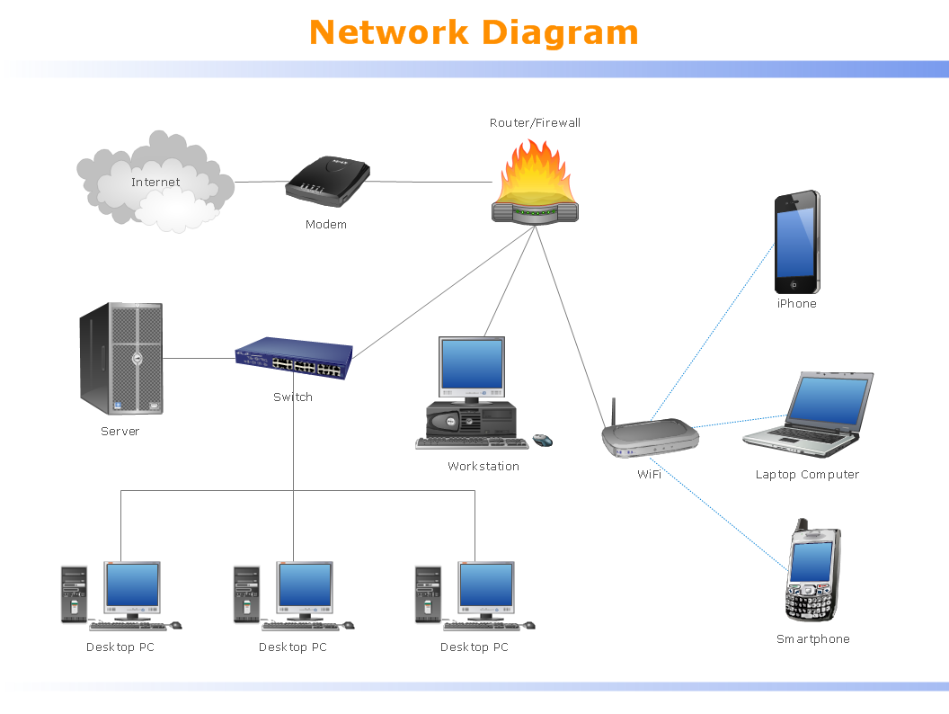

1. **List how many network devices and types of cable used and give its details.**

**Network Devices:**

1. **Router/Firewall** - Manages the traffic between the internal network and the internet, providing security by filtering incoming and outgoing traffic.
2. **Modem** - Connects the local network to the internet by converting digital data from a computer to analog signals and vice versa.
3. **Switch** - Connects multiple devices within the same network, allowing them to communicate with each other.
4. **Server** - A powerful computer that provides services, data, and resources to other computers within the network.
5. **Workstation** - A computer connected to the network, typically used for business or professional work.
6. **Desktop PCs** (3 in the diagram) - Personal computers connected to the network, typically used for everyday tasks like browsing the internet, creating documents, etc.
7. **Laptop Computer** - A portable computer connected to the network, typically used for mobile work.
8. **WiFi Access Point** - Provides wireless connectivity to devices like laptops, smartphones, and tablets.
9. **Smartphone and iPhone** (2 in the diagram) - Mobile devices that connect to the network via WiFi.

**Types of Cables:**

1. **Ethernet Cables** - Used to connect the server, desktop PCs, workstation, switch, and router/firewall. These are usually CAT5 or CAT6 cables, which support high-speed data transfer.
2. **Coaxial Cable** - Likely used to connect the modem to the internet service provider (ISP).
3. **Wireless (WiFi)** - Though not a physical cable, wireless signals connect the laptop, smartphone, and iPhone to the network.

**Details:**

* **Ethernet Cable**: Commonly used for wired connections in local area networks (LANs), providing reliable and fast data transfer. Ethernet cables often come in different categories (e.g., CAT5, CAT6), which indicate the maximum speed and bandwidth they can handle.
* **Coaxial Cable**: Typically used for connecting modems to the ISP. Coaxial cables can carry high-frequency signals with minimal interference, making them suitable for internet connections.
* **WiFi (Wireless)**: Used for devices that require mobility or where cabling is impractical. WiFi provides flexibility but can be subject to interference and generally offers lower speeds compared to wired connections.